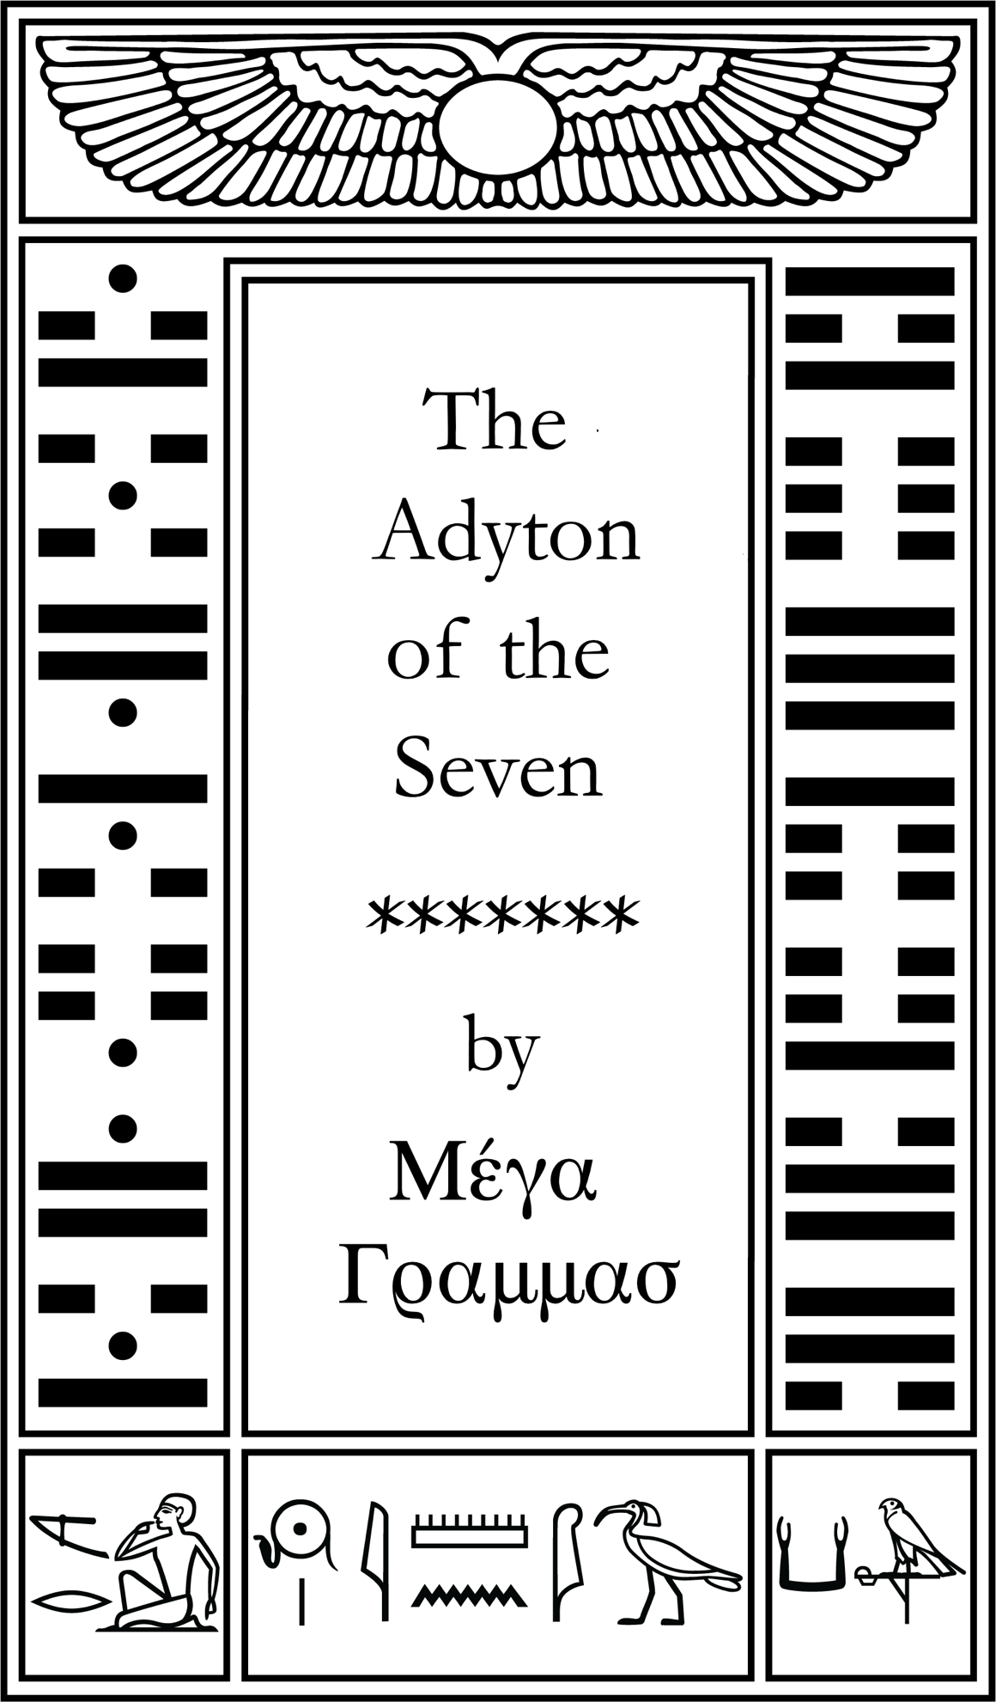

Publication in Class B

The Chamber of the Adepts and the Adyton

The Chamber of the Adepts is a long-standing icon within the Western Mystery tradition. Its origins are found within the Golden Dawn through the Rosicrucians. There is an abundance of information to be found on it, and I will leave this up to the individual Adept to discover. One of the clearest instructions within the Holy Books of MA concerns this chamber, and its uses. Whether one calls it the Chamber of the Adepts, the Adyton of the Seven, or the Sevenfold Cloister, it all means the same.
It is a place of meditation and ritual whose design relates to the deeper mysteries of Ma through its sacred geometry and mathematical synchronicity. Thus, the Chamber of the Adepts now is retitled and reinterpreted as the Adyton of the Seven, which will serve as the Sevenfold Cloister of the Order of the Argentum Aurora.
The Adyton of the Seven is a reinterpretation of the Adept Chamber in terms of the Aeon of MA. There is much within our writings concerning this most celebrated idea. The use of the word Adyton itself is curious, as it means the innermost sanctuary of the temple, a place that only the priest could enter, and from which their oracles were received. This word is synonymous with “the Holy of Holies” or “the Inner Sanctum”. Within the structure of the Greek temples, the Adyton was a room within the Temple proper (ναός), whose access was restricted. This holds an interesting history, for in the Ptolemaic period of Egypt, the Adyton referred to that which was hidden inside the Inner Sanctum of the Temples, existing in a darkness meant to represent the primordial darkness before creation. Archaeologists extended it to refer to the central room of pyramids. Around this room was often a Labyrinth of tunnels and paths meant to detour those who would rob and desecrate the tombs of those buried within.
In Greek, the word Adyton is ΑΔΥΤΟΝ, equaling 825. The idea that the Adyton is concealed within the Temple is shown by the reversal of 825 which is 577, meaning, in Hebrew, “the Concealed of the Concealed”. 577 is also the sum of the first 3 words of the MAAT notariqon, meaning “Sanctuary of the Hidden Goddess”.
תעלומה אמון אלה מקדש Words = 1128
TOLUMAH AMUN ALH MQDSh
Mystery Concealed Goddess Sanctuary
551 97 36 444 = 577
And herein lies another mystery, for 577 is the 106th Prime, and this is the differential of 14° Cancer, the location of Sothis, which many consider to be the Silver Star, and represents this Hidden Goddess. In the Old Aeon lodge paradigm, the Order of the Silver Star was the Concealed of the Concealed orders and attributed to the Supernal Triad. These 3 Orders consist of 10 Grades. Yet in our Mysteries, these 3 Orders become symbolic of the 3 States, and are not in any sense hierarchical, but coexist within each other, and represent an initiatic poise that is inborn within the Adept.
Taking this one step further, we understand that the true A∴A∴ is represented by the 3 Gods of the 3 chapters of Liber MA:
- Maut, the Goddess of Chapter 1 = 447
- Amun, the God of Chapter 2 = 747
- Khons-pa-Khart, the Child-God of Chapter 3 = 447
Thus, we have 447 + 747 + 447 = 1641, which is the Conrune of 825 – Adyton. Between them lies the Differential of 816, which is 8 × 102, 102 being the value of AMVNH, which is the Word of the Lauds. If we consider 816 as an ordinal of a Prime, the 816th Prime is 6271, which is the number of words and verse numbers in the Global Sum of Liber MA. The Reversal of this huge Prime is another prime, 3797, the 528th Prime. This is the side of a square whose area is the Global Sum of Liber MA.
Within this context, we can understand that there is a lot going on with these numbers. That is the nature of the Gnosis of the Aeon of MA, that there is a mathematical exactitude that transcends what we normally understand to be Synchronistic Gematria. To use the ordinal value of a Prime within this context is a testament to the higher intelligence through which this system was made to manifest. For 816 + 528 = 1344, and this is the sum of the Differentials of the MIX Founding Heptagon, the Order through which the Current of the Aeon of MA came into being. And when we MIX these two huge primes together, 6271 -> 3797 = 1968, which is the rounded value of the Circumcircle of the Psyche Heptagon (whose edge length is 1708). 1968 is the reversal of 656, which is the Greek word, “H TEΛETH”, the Initiation. This gives us a Triad Sum of 12036, which is 17 × 708. 17 is the Triune representing Venus. 708 is the TQ of “Also the lady Maat with her feather and her sword abode to judge the righteous”. This represents the Adjustment Atu, which is assigned to Libra, ruled by Venus.
We can then consider the Adyton to be the central chamber concealed within the Pyramid, which is symbolic of the Queen’s Chamber, or “the Sanctuary of the Hidden Goddess”. It is at the very heart of the Pyramid, the heart of our Mysteries. It should be noted that within the MIX Mysteries, there is no consideration of Outer Order versus Inner Order, it is all One Order, as it is said “The Way is open to all.”
825 as the gematria of Adyton in Greek also points to another mystery found in Seven Spirits: the value of the following phrase “in the skein of the golden coppery leaden silvery mercurial tinny and ferric veins”. Through this, we can then represent one of the 7 sides of the Adyton with one of the 7 metals. In TQ, these metals equal 534, whose Phi Triplet is 330:534:864. This is highly significant, as 330 represents the Seed of the AMWN Hexagrams, whose divisors equal 864. It is a rare occurrence in which we find a number whose divisors sum a number in Golden Ratio to the number itself. We will see, further down, how we can derive the Greek Vowels from this seed of 330.
Given the importance placed on the Chamber of the Adepts, or the Adyton, it calls for us to reinterpret this most precious of Mysteries to align it with the Aeon of Amon. We will leave behind many of the concepts and ideas that those Old Aeon orders had concerning the Chamber of the Adepts. In full, verse 7 of The Book of Dissolution reads:
7. The adyton of the seven is Fire and Ballistic and Wood and Waves.
The total for this in TQ is 625, and this gives us a clue to its purpose and construction. Firstly, the Φ of 625 is 1011, and we find this gematria in Seven Spirits:
“The wayward must journey home, their paths will become clear if they vibrate with the light that is their own signal in the Eye.”
We can then see that one of the purposes of the Adyton is to give a home to the wayward, as this idea of the Vault being a home is also presented in The Book of Dissolution, verse 46, which reads, in part:
It is home to weary wanderers inside its very vault.
And again, we find this concept in The Time of the Trinity:
“Make thy home a castle, and thy castle a fortress, and thy fortress a bastion and thy bastion a beacon and thy beacon a beak and thy beak a beckoner.”
Here we find a TQ value of 1404, which is the sum of the letters of the Three Grades of Liber AL: Yod – Zain – Peh, spelled doubly in full. The Adyton is then the home of the Initiate, weary of this world. It is a place of rest and meditation, yet also a place of exploration and discovery. It is then designed to be exactly that. It is a place that affirms the Life Force and vibrates with the fullness of our Mysteries.
For the Old Aeon, the Chamber of the Adepts was the Tomb of their mythical founder, Christian Rosenkreutz. And much of their symbolism surrounds this, including the Pastos, which is the central piece of the Chamber of Adepts. The Ritual of the Adeptus Minor is to celebrate the ‘dying’ of the Ego in a carnal sense, and its resurrection towards a more spiritually attuned mind set, in preparation for the Trial of the Adeptus Exemptus, whose job it is to take on the Abyss. One of the salient features of the Adyton is that the idea of the ‘dying god’ is transformed into the Charioteer, with the central piece, the Pastos, becoming the Throne of the Charioteer.
“And as the Living Spirit wilt thou come to thy ecstasy as surely as the Chariot will come to the Temple of the King”
As to the symbology surrounding its construction, we find that the Rerune of 625 is 347, and this is the Hebrew word for APRIVN, meaning Chariot. It should be noted that 347 is the 69th Prime, and 69 is the value of skein, which in Seven Spirits is composed of the Seven Metals. Thus, the Chariot itself is composed of the 7 Metals that make up this skein. With this equivalent of the Chariot, we can then reformulate the Adyton to represent the Merkabah (Chariot) and the Universe in which the Merkabah exists. It then is no longer a Tomb, with all its pseudo-Christian symbology. I have often wondered why the Prophet never reformulated the Chamber of the Adepts according to Thelemic symbolism. A commentary does exist, but it escapes me why he never ‘purged’ this particular ritual. Perhaps it does exist, and it is a closely guarded secret, but this is doubtful.
We are told that the Adyton IS “fire, ballistic, wood and waves”. This is an interesting take on the 4 traditional elements. The verse itself points towards a ‘four-ness’, being that the differential between 625 and 347 is 278, which in Hebrew is ARBOH, the number 4. Further, 625+347 = 972, whose reversal is 4. These “elements” can be taken to represent many things. One of them is the 4 states of matter:
Fire = Plasma
Ballistic = Gas
Wood = Solid
Waves = Liquid
It can also refer to the Alchemical Process of Distillation, where Fire is the heat applied, which in turn, turns it into vapor that travels upward into the condensation tube, called the serpentine coil condenser, where the vapor is solidified into a liquid.
These four elements, which I have come to think of as the Amun Elements, total 206 in TQ. 206 is the Conrune of 157, the Φ of 97. The transition of 97 through 206 gives us 69, which as we noted above, is the word skein, and that the 69th prime is 347, the Chariot. The Transitional Sum of this triad is 372, which is the Hebrew word for 7, ShBO. Or we can take the phrase “The adyton of the seven is Fire and Ballistic and Wood and Waves” and compare the subject to the predicate, giving us ‘The adyton of the seven’ into ‘Fire and Ballistic and Wood and Waves’ making the Triad 248 -> 362 = 485. 485 is 5x97 and is the number of lines in the Indestructible Tarot.
A final note on 206: it is the Converse of 466, which points toward another grouping of four, namely the 4 Sphinxes.
j k
206
The Four Elements of AMUN
- Wood
- Waves
- Fire
- Ballistic
k j
466

The Four Totems
- White Goat
- Green Crocodile
- Red Dragon
- Blue Sphinx

It should not be discounted that 466 is also the value of נוית, NVITh, in Hebrew, the Star Goddess. We find that the Φ of 206 is 333, which in TQ, gives us “the message of the star goddess”. This is one of the goals of the Adyton, that it represents her message in the form of Geometric Mysteries. One mystery is formed herein by the Pythagorean Triangle, for if one Leg is 206, and the other leg is 466, it gives us approximately 509, the 97th Prime. 509 points to another grouping of 4 given in the Book of Twelve Ages, verse 34, in part:
“In the throne room is Juppiter, on a chair carved by hand with the regalia of eagle’s talons and lion’s manes and bull’s horns and dolphin’s fins.”
The regalia is ‘eagle’s talons, lion’s manes, bull’s horns, and dolphin’s fins’. These 4 sum to 509.
Having proven its purpose and intent, we have now come to the design aspect of the Adyton. This will be done in 5 parts, as follows:

- The Adyton’s shape as a prism of Light, and the importance of Color.
- The measuring system that will be used for the Adyton.
- The Heptagon of the Adyton and its values.
- The Floor representing the Foundation of our Work, being both the Vehicle and Body of our Mysteries.
- The Walls representing where this Work takes place: the Starry Abode of your travels. It is through them that we express the Science and Art of our Magistery.
- The Ceiling, representing the Pinnacle and Aim of our Work.

The Prism of the Adyton
One of the aspects of the reformulation of the Chamber of the Adepts is the use of color. The word “light” appears 26 times in our Holy Books and is a clue to how to approach the question of color. The concept of light is dealt with in the very beginning of Seven Spirits:
6. The Star Goddess awaits and attacks withdraws and advances into the fabric of your being. She illuminates the emptiness with her rivers of light. She gives this number 182 and provides the seven with all they desire
7. She is not on the mountain She is the mountain She is not in the looking glass, she is the glass and the light therein.
8. Heed her call, absorb all of her colors. What seems white is a myriad combined, each a strand of her hair, a glimpse of her loveliness.
I would call particular attention to verse 8, which implies that white light is a myriad combined, and this is what the RGB color scale represents: the more combined and the higher the value, the closer you approach pure White Light. This verse is valued at 1063, the 179th Prime, for which we have the TQ equivalence “the Chariot of the Sun”. The reversal of 1063 is 823, the 143rd prime, which needs no introduction. Her rivers of light, in this context, would then be the 26 colors of the Trigrams, which then become a myriad combined to form the colors of the 728 Ditrunes, which become attributed to the Walls. This Light then illumines the emptiness with her loveliness. Remember that we are told in the first verse of Seven Spirits:
“The entire cosmos is discovered through the empty net of the Eye.”
It is the Eye the perceives Light, or its combinations that give color through its different wavelengths. So, to this end, I have designed what I call the Amun Color Map, based on the Phi Ratios of 97, and encoded into a RGB Color coding. This Color Map is particular to the Adyton coloring and uses color to elucidate certain Mysteries.
The idea behind the Amun Color map was to base it on the phi ratios of 97. We have the following step values: 60, 97, 194, and 254. I decided on a limit of 254 instead of 255. This represents the Pure White Light that is unapproachable. This limit also hides 255, because “Amun is the Concealed One” = 255. For equivalences, we find the following values in TQ:
60: Shiny
97: Night-sky
194: this tempered white light
254: the sun-drenched sky
We can then create a map of colors from these values. It will be shown later how they can be used to encode certain color mysteries in the values used for the individual colors one may choose to create.
The Grand Sum of all the numbers used is 10017. This number is 27 x 371. 371 = “Their plumage is like the peacock in the vessel.” This is a reference to a stage in the alchemical process. According to the pictures depicted in Splendor solis oder Sonnenglanz, a major alchemical work from the 16th century, this stage is ruled by Venus. To quote Adam McLean, a prominent authority on such subjects:
“With the Peacock stage, the alchemist has entered into the inner experience of the astral world, which initially appears as ever shifting patterns of colour. This experience is often symbolised in alchemy by the image of the peacock's tail with its splendid iridescence of colour.”
The reversal of 10017 is 553, which we find in Seven Spirits:
She is not in the looking glass, she is the glass and the light therein.

What an amazing construction this is. We have 27 Trigrams representing the RGB color spectrum, which in turn, we are told, is the very fabric of our Star Goddess. Following this lesson, we are instructed:

Heed her call, absorb all of her colors.
This phrase is 286, the Reversal of 442, MAAT! If we separate just the colors from the gray tones, we get the gray tones as 1053 and the colors as 8964. Amazingly, 8964 is 12 x 747 = Amun. The reversal of 8964 is 652, which is equal to the phrase “The light is already there the time is already come. Sound is already heard”. 1053 is the reversal of 13, the Sun Triune. When we add the reversals, 652+13, we get 665, 97 x Φ⁴, or 5 x 133, the name of Amun in Tiferet on the Tree of Life.
As previously demonstrated by Frater O.L., the colors, when seen in the color wheel, form themselves into 8 sets of Grand Trines, being equidistant from each other. These 8 numbers are:
254 | E | Y | X
314 | O | N | U
351 | J | Z | W
448 | V | D | S
508 | H | ) | T
448 | R | B | F
351 | P | A | G
314 | M | K | Q

In this pattern, all 8 numbers sum 2988, which is 4x747. The first term, 254 is half the 5th term, 508. These are attributed to the 4 Elements, Sol & Luna. 254+508=762, which is Greek for περιφανεια, which can mean “full Knowledge”. Its root means “to appear, appear forth, or shine.” The other 6 values ‘surround’ 762, being composed of 6 planets and 12 Zodiac signs. These sum 2226, which is 7x318; 318 being the value of Helios, Sol. When we transition 762 through 2226, we get 5877, which is 9x653, an AMWN Hex. Thus, its reversal gives us another AMWN Hex, 575, providing a direct AMWN hex pair.
For these values, we have the following equivalences:
254 | the sun-drenched sky
314 | a stand for white and blackness
351 | And the triumphal Chariot appears to the people
448 | Meriba is but one aspect of this unfoldment
508 | Katalysis is the Word of the Aeon It flows from all directions

Having established this color code, we can now keep in sight one of the many instructions from The Book of the Crystal and the Peacock:
Light is the message, in all its forms.
The Adyton is a Vault of seven sides, so the geometry of the Heptagon plays a vital role in our design. The word heptagon itself is of Greek origin, επτάγωνο, and equals 1309, which is 7x187. For 187, we have the TQ equivalent of “on seven sides.”
Having been instructed that the Adyton is of Seven Sides, we now explore the possibilities of what to do with these seven sides. What is amazing is that this can be derived from the colors themselves. Frater O.L. presented the idea of taking the Trigram totals of the 8 Equidistant points on the Color Wheel, and multiplying them by 28, (which gives a doubling of the values in terms of TQ). The chart is as below:
37 | Pearl | 1036 | Pandora – Giver of all
59 | Malachite | 1652 | Apotassō – to separate
34 | Exalt | 952 | Xarisma - a spiritual gift
60 | Gems | 1680 | Xristou – anointed
38 | Sight | 1064 | Aigyptos - Egypt
46 | Galaxy | 1288 | Péxus - Cubit
20 | Opal | 560 | Ipsos – Height, crown
54 | Fires | 1512 | Apokalypsis - Revelation
348 |  | 9744

The sum of the Trigrams is 348, “Mix the fire and the water; all shall dissolve”. The Fire is the warm colors, while the Water is the cooler colors. Thus, 348 x 28 = 9744 = 3 x 3248, the Sum of the AMWN Hexagrams. Seen another way, 9744 in Ternary is 111100220, which reverses to 22001111, which is 5872, whose reversal is 111100022 = 3248, the sum of the AMWN Hexagrams. When we transition the Warm colors, summing 3612, into the Cool Colors, summing 6132, we gain the transitional result of 93 = Thelema.
We can then see that with the use of Light and Color, the Adyton is then a seven-sided Prism, through which Light is distilled. As we know, the Walls of the Adyton are represented by the Seven Planets, and the 7 Double Letters of the Hebrew Alphabet, attributed to those planets, equal 709. The Reversal of 709 is 431, and this is the Greek Word, πρίσμα, prisma, the root of our English word prism.
431 is the 83rd Prime number. The Importance of 83 within this Gnosis cannot be overstated, since 14 × 83 = 1162, the numeration of Katalysis. (Note: 14 + 83 = 97!) We can then proceed on the premise that the Adyton is a seven-sided prism and make certain calculations that derive from this. One should note that a seven-sided prism consists of the following:
- 9 Faces, being the 7 sides and the top and bottom.
- 21 Edges, each edge represented by a letter of Liber Carrus
- 14 Vertices, which can be seen as representing the dual nature of the Double Letters attributed to the Planets.
The simple sum of these 3 numbers is 44, which is DLI, the Hebrew word for Aquarius. This word equals 528 in full, and we saw the importance of the 528th Prime above. The reversal of 44 is 684, which is the Greek word ‘MΥΣΤΗΡΙΟΝ’, Mysterion, counted with a stau.
If we multiply these numbers instead, we obtain 9 × 21 × 14 = 2646. This is an interesting number as it is also 7 × 378, 378 being ShBOV in Hebrew, the word for Heptad, and there are many heptads one can choose from in our Gnosis. We find this number to reverse to 226, which is a very intriguing result.
- In TQ, we find “NU is the breath of what I AM”. This is an obvious reference to the MA – I – ON formula. We can transliterate the TQ attributions of these letters to Hebrew: English NU is Scorpio and Mars; English AM is Virgo and Aquarius. In Hebrew these are the letters Nun + Peh + Yod + Tzaddi = 50 + 80 + 10 + 90 = 230, the Conrune of 133 with the 97 Differential.
- In Greek, we find ‘Η ΙΣΗ’, ‘The Equilibrium. This is a hidden function of the Star Atu, represented by Aquarius.
- In Hebrew, we find the word ‘צפון’, meaning hidden or concealed. And what does it conceal? In full, with finals, this word equals 957, which is Liber LUXORAT, A:5:
“The steeds and the driver, the wheels and the carriage.
Mount thyself in the center for ease of motion.”
We see that the symbology of the seven-sided prism is very important to this Gnosis. We can then apply pure math to the prism. Each wall is divided into 13 units per edge, and 8 units in height. This gives us 104 squares per wall, so that all 7 total 728 Ditrunes. This fact will be gone over in the section on the Planetary Watchtowers. Yet the pure geometry of the Adyton as a prism is as follows:
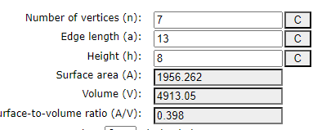
This gives us a total volume of 4913, which is 17³! 17 is the Venus Trigram, whose orbital mechanics are fundamental to the Celestial Geometry of the Adyton. We can also understand this, then, as 17 × 289. 289 is the Differential assigned to 15° Cap, placing it on the 185 Heptagon, and assigned to the Venusian wall, or Watchtower.
Most significantly, as will be shown later, the sum of the Central Columns of the Walls is 133 × 156, and 133 + 156 = 289. 133 and 156 form a Perfect Pythagorean Triplet as 133:156:205, with 205 being the Hypotenuse of this Right Triangle.
There are several ways to interpret this, yet it is the cube of the Venus Trigram which emphasizes the importance of Venus to this astro-cosmology of the Adyton. Looking at the surface area, we have the Walls being 728 and each of the upper and lower Heptagons having a surface area of 614 each, giving us a total surface area of 1956. This is equivalent to the Secret Tetragrammaton Formula of AUMN MA, (see Bulletin 62).
Creating a Triad between the surface area and the volume gives us 1956 → 4913 = 3457, which is the total of new words (including 1 new verse) of Liber Ma compared to Liber L. This is the 483rd Prime, which is the Hebrew word, מזלות Mazloth - Constellations, the sphere of the zodiac. Since this transition is the number of new words in Liber MA, we can see this as the inherent textual change from the Aeon of Horus to the Aeon of Ma. 3457 is also the Greek word κινεω in full, which means to move, to change or innovate. Liber Ma is assuredly the innovation of Liber L to expound the Mysteries of AMOUN.
We can then ultimately discover the true purpose of the Adyton through the Triad of the word Adyton itself, and the volume that Adyton contains: 825 →4913 = 4111, the 566th Prime, and 566 is the gematria of the Hebrew word TKVN, or Restoration.
Now we can integrate 3 key concepts through their Triads with each other. We have the following:
- 10017 representing the fullness of the light spectrum as an RGB code based on step values of 97.
- 3457 which represents the integration of the surface area to the volume of the Adyton based on a prism whose edge length is 13 and height is 9.
- 2646 which represents the multiplication of the parts of that Prism.

The sum of the three Triads made between these values is 37264, which is 17 × 2192. 17, as we saw above, is the basis for the volume of the Adyton itself. It is also the Hebrew word חוּג, meaning to move in a circle or circuit. 2192 is the Hebrewשמן משחת קדש , ShMN_{f} MShChTH QDSh, the Holy Oil of Anointing. Thus, the combination of Light, in the Prism that is the Adyton and its sacred geometry, is an activation of the Holy Anointing Rite within the Adyton.
The Holy Anointing Oil of Amun is composed of 7 blended oils as stated in the Book of Seven Minstrels. These have a value of 1510 (Epistle 23). Making a Triad between the Hebrew title of such an oil, and the names of those oils: 2192 → 1510 = 5166. Making a Triad of this with 4375, the value of the 7 words of the Anointing, gives us 5879, the 774th Prime.
Yet this section is all about the Adyton as a prism of light. We then take our result of 5879 and make a Triad with 2988, (which represents the 8 Grand Trines of the Amun Color Wheel) and get 19, whose Mystic Number is 190. This reminds us that the primal Triad of Creation is 774→190 =1577, the value of the term ‘Ain Soph’, representing the ultimate origin of the source of Light within the Adyton. This is fully revealed in the works of Omega Logion: making a Triad of AIN SOPh (the Limitless) with AVR (Light) is 1577→207 = 757, the value of MAION. Thus, the Light comes from the Limitless.
The Cubit of AMUN
We can now establish a system of measurement for the Adyton. There are a lot of systems out there, from metric, imperial, and the more ancient forms, such as cubits. For the Adyton, we will be using the royal cubit as the measurement standard. The cubit is basically the measurement of the elbow to the fingertips. Thus, everyone has their personal cubit measurement. From this we have, in a royal cubit, 7 ‘palms’ and 28 ‘finger breadths’. To celebrate the Magus of the Next Aeon, we shall base the length of this cubit on his personal cubit, which is 19 inches. In Hebrew, these measurements are known as follows:
- Cubit = AMH (gematria 46) (19 inches Imperial)
- Hand-breadth – TPhCh (gematria 97) (2 5/7ths Inches {or 19/7ths}; 2.714 Imperial)
- Fingerbreadth – AtzBO (gematria 163) (19/28ths of an inch; .679 inches Imperial)
And herein is the beauty of this system. AMH = 46, which is also BDIL, Tin, the Metal of Juppiter. When we add the Gematria of all 3 of these units together, we sum 306, which is the reversal of 46, the value of Cubit! Lastly, the Converse of 46 is 514, which is the sum of the Letters attributed to Juppiter, in Full, in Liber Carrus. Tin is the metal of Juppiter.
97 needs no introduction, and since there are 7 of these, we produce 679, whose converse is 133, which can be looked at as the length of 7 Cubits. In full, these letters are 922, whose differential with its Conrune, 1601, is 679. To reinforce this idea of 7 handbreadths in the Cubit, the Hebrew H-ShBOH, The Seven, is also 922 in full.
The final unit, the fingerbreadth is 163, whose reversal is 747. 28 of these produces 4564, whose Conrune is 2324, twice the value of Katalysis! What an amazing result this is, that the Word of the Aeon and the God of the Aeon are concealed within this ancient measuring system.
46 + 679 + 4564 gives us 5289, which is 43 x 123. 43 is the Hebrew word MG, Magus, while 123 is ChHN HGDVL, High Priest. We have the union of the High Priest and Magus in one Office as the regent of the God of the Aeon, AMUN.
The traditional cubit is normally between 20 to 21 inches, so to differentiate this measurement from the traditional Cubit, this unit of measurement shall be called a Z’Bit. The Z is valued at 19, while the word bit means a segment or part. The Hand-breadth measurement shall be called the I’Bit, as 2 5/7ths (19 7ths) inches is 69.9 mm, rounding to 70. The I is then a reference to “eye”, which is the letter Ayin, being 70. The final unit shall be called an A’Bit, because 19x28 = 532, and this is the Greek Letter Alpha spelled in full. The first letter of each of these units, ZIA, represent, in Hebrew: Gemini, Virgo and Air. All three of these can be attributed to Mercury. As Greek letters, in full, they equal 1959. 3 x 1959 = 5877. The number 5877 is the result of the transition, see above, between the Luminary and non-Luminary colors. Both numbers are reversals of 575, except the 1959 is a Septagram, and 5877 is an Octogram. It should be noted that this is an esoteric measuring system that is applied to the Mysteries of the MIX. The sum of these 3 units, Z’Bit + I’Bit + A’Bit, equals 111 in TQ.

The Heptagons of the Perimeter
The number 1404, the sum of the letters of the Three Grades, spelled doubly in full, shares a very special relationship with 625, which is the value of Dissolution: 7. “The adyton of the seven is Fire and Ballistic and Wood and Waves”. When we make the side length of a heptagon equivalent to 625, we gain the following results:
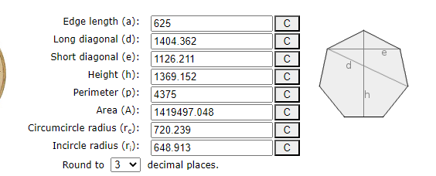

When we use 625 as the edge length, the long diagonal becomes 1404! This is also the value of Liber Graduum, Initium:70:
“The Adept has fashioned the jewel as a token of mastery, majesty, mystery too. The mark of the Master has facets that focus the Light of the Living into the third Eye.”
This is one of the very functions of the Adyton, to focus the Light into the Third Eye, which in occult anatomy, is the Pineal Gland, represented by the pinecone. The short diagonal is then represented by 1126, which is the Devil Atu in Liber Spectaculi:
“From West and East the blood is mixed, betwixt the two the third is made. And by this Holy Child will come the Silver Star in the heptagon.”
We could interpret this West and East as referencing the 2 diagonals, which when ‘mixed’ produces 740. These are the sum of Series 1 and Series 2 of Liber Carrus, leaving us Series 0 whose sum is 747, AMUN, whose differential is 720, the Circumcircle Radius of this very Heptagon!
When we make the Silver Star within this Heptagon, we have (1404.36 × 5) + (1126.21 × 2) = 9274.2. which we round to 9274. This is 2 × 4637, 4637 being the 625th Prime.
What is most significant is the perimeter: 4375, or 7 × 625. In the Book of the Seven Minstrels, we are told:
“These mark the points of a sigil and bless the Adept with its potency. Use cinnamon or myrrh or olive or olibanum sandalwood, acacia, or mint. A combination or a single oil. Bless thyself with the words
Atun Mekhare Saphet Alon
Teshet Noser Tefnut”
We transliterate these letters into Greek, they sum 4375, the same as the perimeter of this Heptagon.
ΑΤΥΝ | 751
ΜEΚΑΡΕ | 171
ΣΑΦΕΤ | 1006
ΑΛΟΝ | 151
ΤΕΣΕΤ | 810
ΝΟΣΕΡ | 425
ΤΕϜΝΥΤ | 1061

When we transition these Seven Words through each other, they sum 11601, which is the Reversal of 1681, 41², which can also be seen as MA x MA. Each of these can be seen as a Name for one of the Seven Minstrels and attributed to each of the Walls.
We now look at 625 as a Ditrune itself, and find that its Conrune is 440, which is the sum of the Seven Metals as they are presented in Liber MA. The Atomic Numbers of these same metals add to 393. This is also the result of the Transitional Tree of the LUXORAT planetary chapter order as follows:
“The transgrams of this planetary trigram sequence sum to 76 = UNITY, the first word of the Book. The Transitional Triads can be continued, using the first set of six Transgrams, and then making Triads out of them, etc. The final trigram is Mars, and this is the Ruby set in the Diadem of the Queen.

0 u v k r e q
n z i g f o
d g z q k
w i p s
p w b
i r
u
26 > 25 = 24; 25 > 22 = 19; 22 > 17 = 00; 17 > 14 = 11; 14 > 13 = 12; 13 > 16 = 10 (sum = 76)
24 > 19 = 23; 19 > 00 = 11; 00 > 11 = 19; 11 > 12 = 16; 12 > 10 = 17 (sum = 86)
23 > 11 = 08; 11 > 19 = 00; 19 > 16 = 04; 16 > 17 = 15 (sum = 27)
08 > 00 = 04; 00 > 04 = 08; 04 > 15 = 20 (sum = 32)
04 > 08 = 00; 08 > 20 = 14 (sum = 14)
00 > 14 = 25 (sum = 25)
Grand total is 133 + 76 + 86 + 27 + 32 + 14 + 25 = 133 + 117 + 143 (sum = 393)
We then take this result of 393 and the number of MA squared, 1681, and make a Triad of them to reveal the hidden number therein:
1681 > 393 = 1295
This reveals to us the esoteric dimensions of the Adyton, for 1295 is 7 × 185, with 185 being the Conrune of 97. This reveals the following Heptagon:
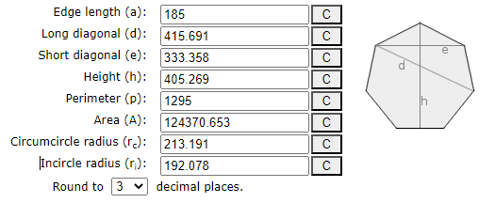
To confirm this use of the 185 as the perimeter of the Adyton, we find that the Differential of 625>440 to be 185. In terms of Ohm’s Law, 625 would be the Current and 440 would be the Resistance offered by the Metals. This results in a Voltage of 185. Just as every Conrune Pair produces a unique Differential, so does the interaction of Current and Resistance produces a unique Voltage. Thus, 185 is the Potential Difference of 625 and 440.
There are many attributes of 185 that can be detailed herein. As the Conrune of 97, its importance to this Gnosis cannot be extolled enough. 185 is the TQ of “the ruby of the ark”, and it is this very ruby that is set in the Diadem of the Queen, represented by Mars, the finale of the LUXORAT Transition Tree.
Probably the most important fact is that 185 as a radius of a circle gives us a circumference that is 1162, Katalysis, the Word of the Aeon of MA; thus, giving us the measurement of the Inner Heptagon. The relationship between 1162 and 1295 is shown by making a Triad of these 2 numbers, 1162 -> 1295 = 822, which is the Hebrew word ShBOThIM, meaning ‘sevenfold’. In this, we know that the English word “sevenfold” equals 133, the number of our Current, and the difference between 1162 and 1295. 133 -> 822 = 1595, which is 5 × 319, AMUN spelt in full. Its Conrune is 919, the Differential of 1162>2081, and the 157th Prime, 157 being the Φ of 97.
The Transgram of 822 verifies the heptagonal scheme, as 822 is also the spelling of the Hebrew letter name Zayin, in full, with sophits. This also has the regular value of 7. With the sevenfold scheme in mind, we shall now examine some of the salient features of the Adyton whose edge length is 185.
Rounding the values of the diagonals, we have 416 for the long diagonal and 333 for the short diagonal.
- 416 = “Recover the beauty and delight in creation”
- 333 = “the messages of the star goddess”
- 333 -> 416 = 253, the Mystic Number of 22, the Jupiter Triune. “the affirmation of His Unity”
Encoded in this is a very special instruction. First, we are told that this heptagon is a message from the Star Goddess, and that by its geometry, we can recover beauty and delight. The Transgram reveals the purpose, to affirm His Unity. It should be noted that Unity is the opening statement of Liber LUXORAT.
Now we take this Heptagon and draw therein the 3 Sacred Stars of our Order, the Star of Lamed (known vulgarly as the Star of Venus), the Star of Babalamun (known vulgarly as the Star of Babalon), and the Silver Star, the star that is particular to our Order.
The Star of Lamed uses the Long Diagonals of the 185 Heptagon. 7 × 415.691 = 2909.837, rounding to 2910. This number is 30 (Lamed) × 97 (Amun). Its Prime Factors sum 107, MA-ION (2 × 3 × 5 × 97). The sum of its proper divisors (σ(n)), is 7056, 7 × 1008. 1008 is the TQ value of Liber MA 3:9:
“Rest! Be strong! Restore them! such are the Ways of the Method of Healing; thus shall the hospice be the place of healing arts.”
The Adyton is assuredly a place of rest, and a place where the healing of Tikkun can be put into practice. As a number, 2910 has an Abundance of 2136, which is the Edge Length of a heptagon whose area is the Global Character Count of the Holy Book of MIX.
The Star of Babalon has a length that is 7 × 333.358 = 2333.506, rounded to 2334. This number is the Rerune of 1162! Because we are reversing the order of the lines from an Octogram to a Septagram, it provides a unique Reversal Differential of 1172, which is from Liber L, 1:63 –
Sing the rapturous love-song unto me! Burn to me perfumes! Wear to me jewels! Drink to me, for I love you! I love you!
One last star to examine is the Silver Star, which is (5 × 415.691) + (2 × 333.358) = 2078.455 + 666.716 = 2078 + 667 = 2745. This is 3 × 915, the value of Liber MA 1: 3 & 4, as follows –
3. Every star and every planet is a whole.
4. Every beauty is permanent, there is one immanence.
This is the Conrune of 4653, which is 3 × 1511, which is the value of Twelve Ages: 30 –
Each thread another breath of the ever-moving wind of Amun, spun like a fine spider silk to hang from and pull together and capture the moving face of eternity.
We then see in the Reversal of 2745 ↓ 677, which is Liber MA 3: 49 –
Amun is the eagle’s fourfold word, the cherubim guarding him in all ways.
Upon close examination of this verse, we see that it totals 677, but it is split as:
335 = Amun is the eagle’s fourfold word 332 = the cherubim guarding all ways to him.
These are both the Conrune and Differential of 667. So, we find that this verse “sets” below the 2745 and 1551. Another thing of note is that 2745 as the Lovely Star whose 5 long diagonals equal 2078 and the 2 short diagonals equal 667. 2708 is the difference of 2745 – 667. Within the channeled works of MIX, we find the following equivalents to 2078 –
Amun will be shown to the people Did you think it an accident that the greatest grave of the pharaohs was undisturbed No It was kept concealed as I am concealed so that the name of Amun would be revealed again to the generations
You must travel inward to find the precious stone the fruit of the vine branch the stone of the wise Amun is the hidden and will always be so Amun is where all power originates the seedbed of the fluctuations in the cosmos.
This is a major nexus, for we see here that the Lovely Star, created by the 185 heptagon, can be called the Silver Star of Amoun, το Αστρον Αργον του ΆΜΟΥΝ. The fact that the sum of the 5 long diagonals is the Reversal Differential between the sum of the 2 short diagonals and the sum of the 7 diagonals together is a very rare occurrence. It all centers around Amoun.
Here we can make a Triad of the Lovely Star and AMOVN in full as 1099: 2745 → 1099 = 6014, which is 2 × 31 × 97, or 31 × 194, TzDQ, and thus:
אל-צדק
The God of the Righteous
The question is how we deal with these Stars symbolically within the Heptagon of 1295. For this, we must turn to the understanding of the Star of Lamed. We must remember that the Star of Venus within the Adyton generates the number 2910, and this is 30 × 97. 30 + 97 = 127, which is the password Amondieux. 30 is the value of the Lamed. In full, 97 as Amun is 319 and Lamed is 74. These sum 393, which is the sum of the Atomic Numbers of the Metals. Above we saw how MA × MA through the Atomic Number sum gave us the perimeter of the Adyton as 1295. In this case, we make a Triad of 127, the Password, and the Atomic Number sum, 393, and gain 572, which is the M Triune over the A Triune, giving us the glyph of MA as a Ditrune.
Below are the diagrams of the Star of Lamed, one with the Hebrew Letters, the other with the attributes of those letters. The key is understanding the 3 levels of attributes. We start with Lamed in the Center. Next is the astrological signs, Aquarius to Leo. The third level would be the Planets. Lastly comes with what remains: 4 signs and the 3 Mother Letters. There are several other ways in which we can categorize these groupings, but these 3 are what concern us most.
A | B | Diff Trans
225 | 709 | 482
709 | 531 | 581
531 | 225 | 324
Working with the sum of the Letters of each level, we can tabulate the following Triads. The sum of these triads is 1387. 1387 is Liber 813 1:6 --
“Thou hast appeared unto me as a young and brilliant God, a god of music and beauty, even as a young god in his strength, playing upon the lyre.”
Later in this essay we will see how the constellation of the Lyre played a very important role in the founding of the MIX. In the Tarot of Amun, this verse is attributed to the Lovers Atu, whose ternary is 485, 5 × 97. It should also be noted that the original Lyre had 7 strings.
Having attained 1387, we make a triad with it through the value of the Center, Lamed, thus attaining the Numerical Quintessence of these Triads as it pertains to these 3 levels. This Triad is 1387 -> 30 = 1862, 14 × 133. Or O AION + AMMON, thus The AION of AMMON.
The Conrune Pairing of 1862 is 1417, which is Hebrew, ADVN_{F} OVLM_{F}, Lord of the Universe, truly an apt description of AMMON. The Differential is 445, which is Liber Trochos:2 –
“The stone of the philosophers is none other than me.”
We then see the synthesis of Ammon, as Lord of the Universe, and as the Stone of the Philosophers. There are 2 Triads left to examine that will bring us to the pith of the Star of Lamed within the Adyton. The Perimeter is 1295 and represents the outer bounds of the Adyton. All the symbolism and activity of the Adyton occurs within this boundary. To understand the relationship of the Star of Lamed to the Adyton, we make a Triad of 1295 -> 1862 = 242 – “The Crown hath seven rays”. And what are these seven rays? This is hidden in the reversal of 242, which is 726. 726 is the value of the 7-lettered acronym, V.I.T.R.I.O.L., using Hebrew letters. Each Ray could then represent a letter of this word, representing the Alchemical process within the vault itself.
This word is rife with symbolism and will be left to the individual adept to study. These letters as Trigrams and transitioned though each other give us 7 Transitions which equal 124, which in TQ, can be “your holy place”. Its reversal gives us 444, the value of MQDSh, meaning Sanctuary. This can be considered the Hebrew equivalent to the word Adyton. These 2 words, from 2 different languages, synonymous to each other give us the following Triad: 825 -> 444 = 2007, which is the Reversal of 143, being the Key Amun Hexagram of the Amun Ma arrangement of the Fourfold Word.
Working the same process of the letters in full, we form a Triad: (937 → 1216 → 2020) = 1995, which equals 15 × 133. This is the Taurus Trigram and the 7 Planetary Trigram. This can be seen as the Hierophant teaching the Mysteries of the 7 Holy Mountains. We then form the next Triad through Lamed, 1995 → 74 = 994, which the TQ of Twelve Ages: 50 –
In her beckoning is stillness In her reckoning is grace
And the fruit of all her labors Is a steady state of grace
The imagery of “stillness” and “grace” evokes a profound sense of peace and balance in the Adepts presence and actions. The "steady state of grace" means a constant, unchanging state of nobility and elegance, showing a flawless state of awareness that is Samhadi. This is the level of awareness that is evoked by the activation of the 3rd Eye in context to the Adept represented as the Pyramidion.
994 is the Reversal of 1138, and this is Seven Minstrels: 21 –
Take oil that has been consecrated and make seven marks for the chakras and limbs. Forehead, throat, heart, & elbows & knees.
Above we saw the role of the Holy Anointing Oil, and here we find instructions of what to do with this Oil. We can then say that the 7 Marks are an acceptance of the “steady state of grace”. Just as we made the last Triad before, we make a Triad of 994 → 1295 = 774, the Seed of the Ain Soph.
Here we look at the normal letters giving us 242, “the Crown hath seven rays”, while the letters in full give us 774, which is the TQ of “it is graven on the Disk that spins in eternal syncopation aligned ever with the Word”. 242 → 774 = 1561, the Diameter of a Circle whose value is 4904, Katalysis in full!
We then add together 242 + 774 = 1016, and this is Kether spelt in full, and is the Crown that has 7 Rays. These 7 Rays are the 7 Planets as evidenced by the Conrune of 1016 which is 2020, the 7 planetary letters in full, which forms the Star of Venus inside the Star of Lamed. The Crown, in one sense, can be seen as the Ceiling of the Vault since the Ceiling of the Adyton is represented by the Star of Lamed. The Triad of 242 and 774 gives us the diameter of the Disk whose spin is aligned to the Word of the Aeon. The syncopation can be seen as the Crown (Kether) dividing itself into 242 and 774, which only occurs when we compare letters in their simple value to letters in their value in full. We then make a final triad of 1016 → 1561 = 702, which is Liber Ma 3:53 –
With my disk I light up the path of the Hierophant and the Priestess, Magus and Death.
Again, we find the symbolism of the Disk. If we look at the value of the letters attributed to these cards in full, we have 12 + 73 + 412 + 756 = 1253. This is the value of the Greek word αληθεύω, which means “to speak the truth”. As we read in Liber Ma 1:42 –
May you see with grace the fountainhead sound and flowing. So with thy lauds; thou hast no right but to speak the truth.

The Floor
The Floor of the Adyton represents the foundation of our Work. It is the operative aspect of the symbolism of Sanctuary. As such, we will begin with the Inner Heptagon that delineates our work; that is the Heptagon of Katalysis.
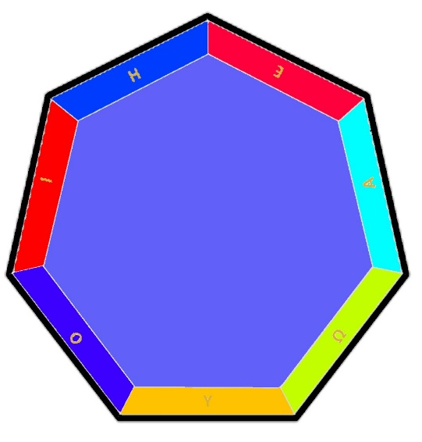
This is the first layer of meaning as we journey toward the center. We first encounter the Greek Vowels. These total 1294. To understand the relationship between 1294 and 1295 we must turn to the mystery of Music. Each vowel is represented by a string on the Lyre, the patron constellation of the MIX. The idea is that the 7 Notes of the scale are not a complete Octave. It must complete itself, the 1 that started the scale must be repeated, thus concluding the Octave. As it says in ancient text – “The one ran and returned”. This whole idea can be applied to the musical Octave. We then have the 1294 of the Greek vowels, and returning adds another 1, making the 1295 of the Perimeter.
Looking at the quadset of 1294, it reveals many mysteries.
A | 1742 | 1294 | B | 448 | Differ. Trans | Septenary
C | 1814 | 1438 | D | 376 | 277 | 7389

We start with the reversal of 1742, which is 1814, which is the Hebrew phrase ‘פְרִי-עֵץ, זֹרֵעַ זָרַע’, ‘the fruit of a tree yielding seed’. The tree which is yielding the seed is then represented by 1742, OTz HDOTh TVB VRO, ‘the Tree of the Knowledge of Good and evil’. This totals 3556, which is 7×508, the TQ of the first verse of Dissolution.
Thus, we find that the Tree of the Knowledge of Good and Evil is the Conrune of the Seven Sacred vowels that form the perimeter of the Adyton. Perhaps one way to view these seeds of the Tree of the Knowledge of Good and Evil is as these Seven Sacred Vowels, “the seven seeds of the Plough”. And the reversal of 1294 is 1438, the Seeds of the AWMN Hexagrams when transliterated into Hebrew.
Further examination of this Quadset reveals 277 as the Differential Transgram. 277 is the TQ of “the perimeter of your Vault”. Again, the precision of our Gnosis is beyond reproach. The Septenary, 7389, is a very special number. As 74 times this number is 546786, the simple sums of the Global Sum of Liber L and Liber MA. The fact that we can attain the simple addition of these 2 works is miraculous. This number represents 74, Lamed in Full multiplied by 7389. 7389 is 9 × 821, the 142nd Prime.
Now let us consider some of the ramifications of using the 7 Greek vowels. Using their alphabetical sequence, we tabulate the sevenfold transitions of the simple value of the Letters:

A | B | Diff Trans
1 | 5 | 6
5 | 8 | 2
8 | 10 | 21
10 | 70 | 40
70 | 400 | 703
400 | 800 | 2160
800 | 1 | 1506
The sum of the Transgrams is 4438, which is 7 × 634. This is the value of Dissolution:55 – “As each cycle completes, it is time for con-temp-lation of another facet of this jewel.”
The cycle is then completed by the returning of the One. The multiplicand of 7 is a Key. Later in this dissertation, it will be shown how 292 dwells within the Heart of the Adyton. Taking 634 as a completion of 7 steps, we draw 634 towards the center represented by 292, and their interaction makes a Triad with 166, which is the edge length of the Inner Katalysis Heptagon. Symbolically, that the vowels dwell within the space between the 1162 and 1295 Heptagons, creating a polygon ring between them. The area of this polygon ring is 24235 which is 131 × 185, the edge length of the Perimeter times the Key Word INVIGORATED.
Much has already been written about the Katalysis Heptagon, and I feel no need to add to the corpus of work. Ultimately, our key numbers are 1162, 1295, and 4438. Each of these are divisible by 7. We can then make the following chart to reflect the 7 within this Triad of numbers:
7 | Multiple | Transition
7 | 166 | 82
7 | 185 | 90
7 | 634 | 451
We gain a Triad sum of 623, the gematria of the first verse ever transmitted: Seven Spirits: 1 –
“The entire cosmos is discovered through the empty net of the Eye”
And as one last transition, 7 -> 623 = 435, the Reversal of 97, AMUN. The use of 1162 and 1295 also puts us on the Heptagonal arrangement of the Zodiac. These are as follows:
First, it should be noted that the Control Numbers of these 2 heptagons are 166 & 185, which sum 351, the Mystical Number of 26, attributed to Luna. We already know that the Sum of the differentials give us the Adyton Polygon Ring. The sum of the Ditrunes involved is 9741, which can be seen symbolically as the Hidden God of the Current, Amun as 97, and the name of the Aeon, MA as 41.
On the 185 Heptagon, the Ditrunes equal 5397 and on the 166 Heptagon, the Ditrunes equal 4344. To understand their interaction, we make a Triad out of them, 5397 -> 4344 = 132. 132 is the TQ value of Dissolution. Dissolution is the title of Atu XIX of the Indestructible Tarot, with a Ternary value of 634, whose value was shown above. Within this verse is “con-temp-lation”, which also equals 132.
Within the area of the 1162 Heptagon are the Three Adornments of the Adyton, being the Throne of the Charioteer, the Pillars of the Sphinxes, and the Cubical Altar. There is a common theme of four-ness, which can be represented as follows:

Fire | Throne | Will of the Adept
Air | Pillars | Stance of the Adept
Water | Altar | Mark of the Adept
Earth | Floor | Path of the Adept
The interaction of the 4 and 7 is highly symbolic in the Adyton, as 4 -> 7 = 1, Unity. We will start with the center and work our way out in describing the fascinating and syncretic symbology of the Floor.

The Throne
The Throne of the Charioteer is the place where we physically sit while in the Adept Chamber. Its design is a truncated tetrahedron, with one point aligned to the central column of the central Wall. Each side is colored according to the CMYK color code. These are the Subtractive Colors which, as will be seen, complement the RGB of the 4 Totems. Also, as taught by Frater O.L., in his commentary on Chapter 2 of Liber MA, these can also represent the 3 Gods of Liber MA. The value of these colors, when added together, sums to 1524. Its Conrune is 780, the value of Ayin in full. This gives us the Differential of 744, which is AMUN-RE-MAAT, (see my essay on 744)
As a truncated tetrahedron, it represents the Netzach Tetrahedron truncated at the 3rd level, leaving 4 levels revealed. Because the measurements of the Throne are based on the phi ratios of the individual Adept, the apex of the Tetrahedron should be aligned to the Adept’s Pineal Gland, thus activating it with 319. Volumes could be written about this gland. Besides the multitude of information available in our writings on the number 319, in TQ it is also the gematria of “all one continuous flow of the Chariot”.
The base of the spine would then be aligned to the Apex of the inner tetrahedron, which is 292, “the seven seeds of the Plough”. This would then give us the following transitional Triad, representing the flow of energy from the base of the spine to the pineal gland: 292 -> 319 = 265! The number 265 is the value of the Ditrune attributed to the empty verse of Liber Luxorat. 265 in TQ is “these seven ways are one”. One way to see these is that since the Walls are the area of our work, and there are 7 of them, each of their ‘ways’ are still but 1 way, expressed via 7 modes.
Taking the Throne as a whole, the total of the 4 layers of the Genesis Tetrahedron is 32049 = 39 x 831. We can look at this as 39 being the sum of the Trigrams forming the Perimeter of the Vault. 831 is Aleph in full, with sophit. Yet it is also the value of Liber Kataluma: 20:
“Let the power of Ma’at course through your veins Your blood transmuted into wine.”

Close attention should be given to the spelling of Maat as Ma’at. This can be transliterated into Hebrew as MOTh, equaling 510, and is the same as the Hebrew word Yashar ישר, meaning to be upright, lawful or to make straight or smooth. Thus, Yashar is Maat in action, as the definition of this word is synonymous to the idea of the moral and ethical conduct of the Maatian Virtues. This is evidenced by the 42 Negative confessions in the Hall of Truth when the Heart is weighed against the Feather of Maat.

E S
366
F )
350
Q B
452
G V
319
E M
372
U O
685
K G
470
G )
323
R G
389
Q M
453

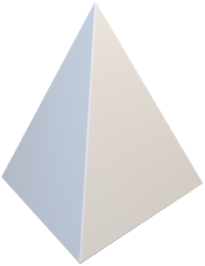
The 3 hidden layers of the Tetrahedron then represent the Adept, consisting of 10 spheres. These spheres sum 4179, which is the circumference of a circle whose diameter is 1330.2, rounded to 1330. This is an unexpected result, as this is the name of Amun in Kether, thus representing the Crown, or Amun in his most rarified form. 4179 is itself 7×597 and 597 in Greek is ἠγίασμένοις - Hagiasmenois, which means sanctified. This can then be seen as a reference to the Anointing Rite and becoming the sanctified of Amun.
319

372
323

453

Above is the upper Tetrahedron formed by the 3 layers, and the numbers attributed to its corners. As we know, the apex of the tetrahedron is 319, Amun in full. The base of this tetrahedron is formed by 323, 453, and 372. These form the skeletal structure in which the remaining six spheres of the top three layers rest, called the Resting Six. These four numbers then sum 1467, the Conrune of 747!
We can also understand this according to the flow of energy, from the base points to the apex, and we do this through transitioning each base point through 319.
- -> 323 = 315 319 -> 453 = 347 319 -> 372 = 428
These 3 total 1090, which is Chronos in Greek. It has been well proven that Amun is Time. The inner 6 that rest within the 4 points equal 2712. This is 6×452, which equals, in Hebrew, SRN HAVPhN, Axle of the Wheel, or as vector points on a cube. We read, then, in Liber MA, 2:7,
“I am the axis now concealed, from the cube to the circle”
It should be noted that the TQ of this phrase is 430, the value of the word ShPN, meaning ‘concealed’. The Wheel, in this context, is represented by the diameter of 1330. The cube is essentially concealed because it is a 3-dimensional figure, while a circle is only 2-dimensional.
Looking deeper into this, we can form transitional triads for the 4 faces of this tetrahedron, which will be called the Pyramidion. We find that the total of the Transitions of the base is 1058, which is Bab-Al-Amoun-Ra. The face consisting of (319 - 453 - 372) forms 1066, this is not only 319 + 747, or Amun + Amun in full, it is also המאור הקטן, the Lesser Light, i.e., the Moon, which rules 319 as Cancer, סרטן. It should be noted that Sarton, Cancer, as 969, is also Amun spelled in full. This highlights the identity of the hidden god of the Charioteer as AMUN.
We then add the other 2 sides together and sum 2172, which is the binary sum of the Tarot of Amun. Forming a Triad of 1066 → 2172 = 41, MA! The total Transitional Sum of this Pyramidion is then 4296, which is 3 × 1432, which is Liber L –
I am unique & conqueror. I am not of the slaves that perish. Be they damned & dead! Amen. (This is of the 4: there is a fifth who is invisible, & therein am I as a babe in an egg.)
This verse was highly significant in developing the I – am – un formula when the MIX first started. The Reversal of 4296 is 808 – ΕΓΩ, the individual identity of Adept. We can then simply add these 2 together – 4296 + 808 = 5104, which is 8 × 319. This would be Cheth combined with Cancer, its sign.
The six hexagrams, or resting points, within this tetrahedron have a sum of 2712. Of these six spheres, the key is 452. Its reversal is 556, which is the last 11 words of Liber Ma,
“The Book of the Lauds is Hidden and Revealed. Aumn. Ma.”
Further, since 2712 is 6×452, we will look at the geometry of 452 as the edge length of a hexagon. And we are not disappointed. The Hexagram is formed by the short diagonals of the hexagon, and this hexagon has a short diagonal of 782.887, so rounding to 783 – BABALAMUN!
If we then understand that the 4 points of this tetrahedron represent the Four Gates, we can then see BabalAmun as the Goddess dwelling in the alcove beyond these Gates. The ultimate integration is in the transition between these 4 gates and the 6 inner numbers: 1467 -> 2712 = 5415, the Conrune of 4179. So there exists a perfect balance between these two aspects of this tetrahedron. This balance is maintained by the differential of 5415>4179 which is 1236, which in turn is the Reversal of 412, the letter Beth, being Mercury and the Magician. And to borrow from the Holy Books of Thelema, we find for 412, “The queen of all of them that are pure upon earth.” Yet there exists another key in looking at the reversals of this Conrune Pair, as follows:
A | 4179 | 5415 | B | 1236
C | 1321 | 1877 | D | 556
The Reversal Differential is 556, the Reversal of 452! As for 5415, we find that its Reversal is 1877, and this is the 288th Prime. We find the Apex of the Tetrahedron to be 319, and the 288th Prime hidden in the Transition of the 4 Corners and the 6 Resting within these Corners. 288 and 319 reference a very special Heptagon, one whose area is the Global Sum of Liber MA. 319 is the Circumcircle radius, while 288 is the Incircle radius of this Liber MA Global Sum Heptagon.
It must be remembered that this Hidden Tetrahedron represents the Adept, thus we have 319 as the Crown, combined with the Resting Six spheres representing, if you will, the 7 Chakras, or points of energy within the subtle body of the Adept. When we transliterate the astrological attributes of Triunes into Hebrew, the Resting Six sum 776, which is 8×97. The Crown transliterates its Triunes into 50. The Triad of 50 -> 776 = 1511. 1511 is Twelve Ages verse 30:
“Each thread another breath of the ever-moving wind of Amun, spun like a fine spider silk to hang from and pull together and capture the moving face of eternity.”
It is here that we must pause and examine these 7 orbs as the idea of the 7 chakras within the Greek language. The simple sum of these 7 is 3031, which is 7 × 433. 433 is the 84th Prime, and there are 84 aspects involved with the Tetrahedron of Netzach, the basis of the Throne of the Charioteer. We find that the TQ of 433 is “the Pyramid of the ceremony of the Death of Asar”. 433 in ternary is 121001, so that adding a yang line to make it a septagram gives us 1121001 = 1162!
The Pyramidion consists of 10 Aspects; removing 7 of them to represent the Chakras, leaves three Aspects that are 323, 372, and 453. These sum 1148, which is also the number which reflects the Altar, shown below. 1148 is also the Greek word Μυστησ, meaning an Initiate.
Yet we cannot just arbitrarily introduce the Chakras into the Adyton as the Pyramidion without a numerical proof for doing so. Above we see the 440>625 Conrune pair giving us 185 as a differential. The leap to the Chakras comes through the Reversal Conrune pair which is 664 > 347 with a differential of 317. 440 is the Hebrew word לקדוש, meaning to make holy or sanctify; it is also the 7 Metals of Liber MA. Its Reversal is 664, which is the Hebrew word במרכבת meaning “in a chariot”. In combining these 2 words, we have לקדוש במרכבת meaning “in a chariot to sanctify” or “in a chariot for holiness”. We can then say that within the Adyton, we dwell in a chariot to sanctify. Yet what is it we are sanctifying? This is shown to us by the difference of 664 – 440 = 224, which is the Hebrew word דרך which means “way” in English. It denotes the path in which you travel in life. This can be an interpretation of Kataluma: 10 –
Over the cobblestones the Chariot rolls To the distant temple along The Way
Bearing the image of the God Burnished with finest gold
Beaming in the sunlight Dazzling the eyes of the devotees.
This verse is 1752; making a Triad with 4296, the Transitional sum of the Pyramidion, 1752 → 4296 = 5976, the sum of the Chakra names in Greek. 5976 = 8 × 747. 8 being the letter of the Chariot bearing the image of “the God”. The reversal of 5976 is 440, the difference is 5536, and this is 4 × 1384, Αποκαταστασισ – Apokatastasis – Restoration, Tikkun. Thus, to Sanctify (440) the Seven Chakras (5976) though apokatastasis (1384). The multiplicand of 4 represents the Four Pillars that surround the Throne. Armed with this knowledge, we can proceed to examine the 7 Chakras, whose Greek names are ultimately derived from Plato in his Timeaus. We can form the following chart:
 |  |  |  |  |  |  |  |  |  |  | Trigram
Chakra (Sanskrit) | Latin | Greek Name | # | Value |  | Pyramid |  |  | Trigrams | Upper |  | Lower
Sahasrara (Crown) | Vertex | Κορυφή | 7 |  | 1098 |  | 319 | G V |  |  | 11 |  | 22
Ajna (Third Eye) | Cerebrum | Εγκέφαλος | 6 |  | 834 |  | 350 | F ) |  |  | 12 |  | 26
Visuddha (Throat) | Collum | Τράχηλος | 5 |  | 1309 |  | 366 | E S |  |  | 13 |  | 15
Anahata (Heart) | Cor | Φρένες | 4 |  | 860 |  | 452 | Q B |  |  | 16 |  | 20
Manipura (Solar Plexus) | Abdomen | Γαστήρ | 3 |  | 612 |  | 389 | R G |  |  | 14 |  | 11
Svadhisthana (Sacral) | Genitalia | Γονάδες | 2 |  | 333 |  | 470 | K G |  |  | 17 |  | 11
Muladhara (Root) | Os Sacrum | Ιερόν Οστέον | 1 |  | 930 |  | 685 | U O |  |  | 25 |  | 10
 |  |  |  |  | 5976 |  | 3031 |  |  |  | 108 |  | 115
I will leave it to the individual adept to engage with their own understanding of the Chakra system. Chakras are specifically mentioned in our Holy Books. The first use is in the Book of Seven Minstrels, marking the forehead, throat and heart points. These sum 3003, which is the value of the Greek word Gnosis in full.
The remaining 4 sum 2973, and this is the Reversal of 895, Kataluma: 29 –
Accept your anointing and be pulled along your course, like the Chariot making its way to the temple.
It should be noted that this is the Differential of 1138>2033, 1138 being the value of the verse that first mentions the chakras and these 3 points. Making a Triad of 3003 → 2973 = 3105. This is the Reversal of 139 – “the central Chakra”. This is referenced in Thirteen Lions –
And so too does the heart power you from within, and so too must it be grasped and captured and its magnificence harnessed to the car of your chariot. There is the graal. The central chakra It beams as it beats. It chimes as it shines. Awaken it and you will be all aglow.
The subject of the numerical aspects and correspondences of the Chakras are beyond the scope of the present essay; herein, I will only express what is related to the Adyton. Here we make a Transitional Series of the individual Chakra names and the 7 numbers of the Pyramidion. These are as follows:

1098 | 319 | 1889
834 | 350 | 2050
1309 | 366 | 1604
860 | 452 | 1997
612 | 389 | 82
333 | 470 | 280
930 | 685 | 1907
These sum 9809, which is 17 × 577. 17, as we know, is the Venus Trigram. 577 was introduced in the very beginning of the present work as “the Sanctuary of the Hidden Goddess”. Yet what is amazing is that the differential of this number is 9797! We shall return to this later. Each of these chakras is also represented by a vowel from the Greek Alphabet. From this, we form a Transitional Series as follows:
1098 | 800 | 1381
834 | 400 | 2072
1309 | 70 | 1900
860 | 10 | 1680
612 | 8 | 472
333 | 5 | 673
930 | 1 | 1619
The sum of these Transitions is 9797! Thus, the sum of the names transitioned through the value of the letters used to represent them is 9797 which in turn is the differential of the names transitioned through the 7 numbers in the Pyramidion used to represent those 7 chakras. We can then sum 1294 + 5676 = 7270, which is 10 × 727, the TQ of “the skein of the golden coppery leaden silvery mercurial tinny and ferric”, the seven metals as listed in Seven Spirits. We then can take that sum and make the following Triad: 7270 → 9797 = 12357. This is then 3 × 4179, the value of all 10 Aspects of the Pyramidion.
Having defined the Hidden Tetrahedron of the Adept, we will now examine the Throne itself. The sum of this Tetrahedron, after concealing the upper 3 layers, i.e., the sum of the bottom 4 layers, is 31997, which is 7×7×653. We can basically spell the name Annu from this arrangement. Annu is an accepted variant spelling of Heliopolis, the city of the Sun, from Egyptian inscriptions. Yet what concerns us most, at present, is the 4th layer of the tetrahedron, upon which the Adept sits while in the Adyton.
This is the upper layer of the Throne, upon which the Adepts sits in their asana of con-temp-lation. It totals 5357, which is 11×487. Just as the Hidden Tetrahedron is a form of a tetractys, so is this layer. And when we compare the two through a transition, 4179 -> 5357 = 61, which is the Hebrew word ANI, meaning “I” or myself, which is synonymous to the Greek word EGO. Thus, the distinctive power of the Adept is based on a duality of what they are within themselves, (the Hidden Tetrahedron), and the foundation through which this is expressed, being the Throne. In full, ANI equals 237, which equals in TQ, “the outpost of the Charioteer”, and is a AWMN Hexagram. As the Adept sits in their asana on the Throne, the spine becomes aligned to 292, which is Linea Virdis Gyrat Universa, “the green line that encompasses the World”. Taking the initial letters of each of these words forms two Ditrunes as follows:
v V u U
l L g G
595 686
The sum of these is 1281 = 21×61, 61 being the Self, the Charioteer, and 21 being the outpost of the 21 letters forming Liber Carrus. The Reversal of 1281 is 385, Shekinah. It is she whose circumference is the Green Line. And who is Shekinah? - “the pure one who dances among the stars” (385).
Transitioning 595 through 686, becomes 531, the sum of the outer seven letters attributed to the Star of Lamed. In this there are the 3 Mother Letters, and 4 Simple letters attributed to the Zodiac. This idea can be applied to the 3:4 split of the 7 layers of the Tetrahedron. The 3 mother letters are the Hidden Tetrahedron; the zodiacal letters are the Throne itself. The sum of the Zodiacal letters is 190, which is the reversal of 774, the Seed of the Ain Soph Aur. These two form a triad with 561, Ditzaniotah, Concealed Mystery.
Just as we divided the Hidden Tetractys into 2 parts, so shall we divide this into its equivocal parts. First is the outer points and the center, which add to 2112. The Inner Six add to 3245. When we transition 2112-> 3245, we get 4375. This is 7×625, which is the value of Dissolution:7. This was commented on above. We have the verse number multiplied by the verse value. 7 + 625 = 632, which is the value of MAUT, spelled in full. The difference between these 3245 and 2112 is 1133, Liber Concluded: 33:
“This is the real world; its reflection into the physical is the plinth on which to rest the world-elephant. It shows only a few of the many attributes.”
1133 is the Reversal of 2173, which is Twelve Ages: 48:
N E
661
U Z
694
B K
557
B U
565
O V
292
K Z
478
R Z
397
) B
722
B R
554
Q A
437

Take your guidance from subsidence The Receptive holds the key
To the pattern of the matter and colliding energy.
Let it ride around the angles and the green perimeter
and the answers are the angels and the bold delimit her.
Now we compare the Transitions of the three corners, and the Surrounding Six, with the center of 292. First are the corners of 139 – 105 – 363 transitioning through 292.
292
661
437
722
139
363
105

The total of these three transitions is 607. This is a very special Ditrune, being the hinge upon which the King Wen sequence rests. Its ternary is 122222, which becomes 31 in base 10 as a binary number (and 133 in base 4). 607 is also AMTh, truth, in full. This word has a simple value of 441, which is a very potent acronym in our Mysteries, as detailed by Frater O.L. in Epistle 25. This word can be represented as “Amun Miqdash Tolumah”, “Amun in the Sanctuary of Mystery”. In this we have all 3 words forming a Transitional Triad of 97 -> 444 =551.
607 is also the 111th Prime, which is Aleph, the Ox. This is the Ox that pulls the Plough, guided by the Farmer. The Ox corresponds to the Horse in terms of Merkabah. It is the Horse that pulls the Chariot, yet the difference is that one is done for peace and the latter is done for war. The Ox pulls the Plough, creating the fertile soil in which to plant the seed.
Moving to the next layer of interpretation, we have 292 transitioned through the Six Surrounding. We can then form the following chart of Transitions:
Base | Orb | Transgram
292 | 694 | 133
292 | 557 | 0
292 | 478 | 349
292 | 554 | 3
292 | 397 | 430
292 | 565 | 19
 |  | 934
U Z
694
B K
557
B U
565
O V
292
K Z
478
R Z
397
B R
554

A lot could be written on this number 934; firstly, it is Liber A’ash verse 6:
“Only in the end shalt thou give up thy sap when the great God F.I.A.T. is enthroned on the day of Be-With-Us.”
In TQ, “F.I.A.T.” equals 26, which is the Lunar Triune. “Be-With-Us” equals 93. When we transition 26 -> 93 = 163, which is the Reversal of 747, AMUN. “The day of Be-With-Us” is a most curious term, having its origin is the Theosophical schools. It refers to the state of para-nirvana.
934 is also the sum of the Seven Signs and their planetary rulers. This is 225 for the Zodiac signs and 709 for the 7 Planets. Making a Triad of these: 225 -> 709 = 482, which is the Greek word “Rhombus”, which carries many meanings. Its ultimate origin has the meaning “to spin, to whirl”. An apt description of the rotation of the Planets within the Zodiac. The sum of this Triad is 1416 which differs from its Conrune 1860 by 444. 444 is the Perimeter formed by the Pillars.
We find 607 to be the Transitional Sum of 292 to the 3 points, and 934 to be the Transitional Sum of 292 to the Surrounding Six. Their simple sum of the Transitions is 1541, which is 23×67. 23+67 is 90, thus Tzaddi, being “The Star”. But as always, the secret is revealed in the Reversal, 1469:
“Coordinate that with your star in blackness and your white goat and your green crocodile and your red dragon and your blue sphinx and all will be well.”

The Pillars
The Pillars of the Adyton are located coterminous to the Throne. The arrangement is based on the geometry of the Vault of Hestia, (see Bulletin 63). This is based on 137 being the Incircle diameter of an isosceles triangle. This forms a very intimate relationship with the Pyramidion in the form of the following Transitional Equation:
4179 → 137 = 5524 = 3031 → 1294
5524 is Αστρον Αργον, Astron Argon, Silver Star, in Full. This is 4 × 1381, which is from Seven Spirits:
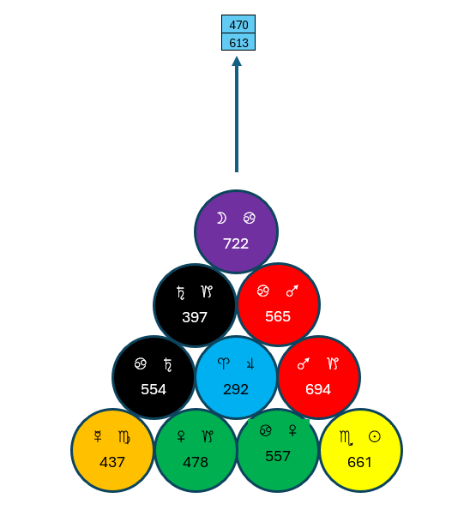
But the summit is hidden in the clouds like Olympus and above them will be seen the Vision of Vitality when the Ruse of Reality is transcended.
This also represents the Transition of Crown Chakra Κορυφή through Omega, the letter attributed to the center. (1098 → 800). 5524 is the Conrune of 4235, which is the word προφήτις in full, meaning prophetess. Thus, we have the Prophetess/Priestess of the Silver Star, the Title of the Priestess Card. Further, Αστρον Αργον equals 945, and προφήτις = 1268. The Triad of 945 → 1268 = 1066, the Lesser Light! This is the Moon, the planet of the Priestess card. Note that the Difference between these 2 values is 323, which is προμήθεια, the Name of She whose vision revealed the Vault of Hestia.
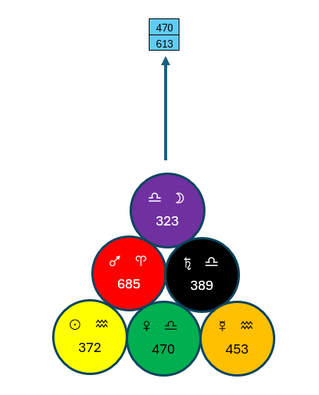
Here we find the differential of 1289, thus 9 × 1289 is the sum of the 7 Transitions created by the Blessing words in Greek. 1289 is also Ηφαιστος, Hephaistos, the God of the Forge, whose Roman equivalent is Vulcan. Here we find the conjoining of two distinct gods that share the commonality of Fire. They both use it in different ways. Hestia is all about the hearth and nourishing with fire. Hephaestus is all about the forge, using fire to create. These are intimately related to the Pyramidion: Hestia + Hephaestus (516 + 1289) = 1805. 3 × 1805 = 5415, the Conrune of 4179. They differ by 773, and herein indicates the presence of the Sphinx.
We must pause and examine all this considering the orientation of the Throne and its relationship to the Pillars and the Walls. 323 is the corner of the Pyramidion that is facing the center of the Central Wall of the Adyton. But just as the Pyramidion is hidden, so must we also look at the hidden differential of this Conrune Pair, which is 143. These sum 466, the name of the 4 Totems in English, as shown above.
We align προμήθεια to be Central. This leaves the other 2 corners, 372 & 453, which sum 825, the value of Adyton. We then make a Triad of 323 → 825 = 1240, the Reversal of 1268!
It must be remembered that this is the Hidden; the Pyramidion is hidden within the Adept as well as the Differential of 143. Now we will look at what is revealed by this Mystical Orientation of the Throne.
Here we see the upper face of the Throne, with 722 oriented towards these 2 same central squares. We simply sum these 3 numbers: 722 + 470 + 613 = 1805, which we just saw as Hestia + Hephaestus.
Then we add the hidden and revealed, and attain 2271, the reversal of 757, MAION. And since the Center of the Throne is 292, we sum 2271 + 292 = 2563, the value of Liber Arma minus the Greek Vowels.
One last aspect to examine in this orientation is the fact that 722 is the alignment of the face of the Throne, then 466 is at the base of the throne. 466 + 722 = 1188, which is also the sum of the Differentials of the seven planetary Exaltation degrees of the Zodiac.
466 has played a prominent role in the development of the Adyton. This is Nuit, and she represents the Starry Canopy of the Heavens that are upheld by the Four Pillars of the Chariot Atu, herein represented by the Four Pillars of the Adyton. The question becomes, how do we represent the Four Pillars?
For this we shall refer to a canonical basis in Liber MA 3:38, which in part, reads:
The light divine, the cosmic ray
Is pouring through the open door
Within the House of Tum I made
For Ra, Khephri, and wise Hathor
I am thy Theban, O Khonsu
The seer Show-the-Light-to-You

The Four Pillars of the Adyton shall then be named after Gods of this canticle. We can then make the following attributes of the Pillars:
- Atun – North-West 741
- Ra – North-East 101
- Kephra – South-East 790
- Hathor – South-West 910
We can then form the following Fourfold Transitional Square from these four numbers:

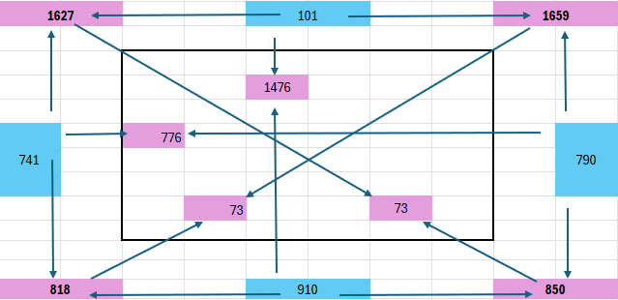

We then sum 2542 for the name of the Four Gods of the Pillars, Thelema, spelled in full! The sum of the Transitions is 4954, of which not much can be said. The “kitchen sink’ sum of the whole figure is 97 × 102, being AMVN × AMVNH, the word of the Lauds. Its Reversal is 3118, which is the Greek word Καμαρα, Kamara, in full, meaning a chamber, a vault, hence our English word Camera.
Here the idea of a camera is that it captures both time and event. We read in the Book of Dissolution, 36 –
36. This captured both time and place, to commemorate both. The event and the position. Both must be honored with a sanctuary
A fuller commentary on this arrangement will be found Bulletin 65, On Liber Iota.
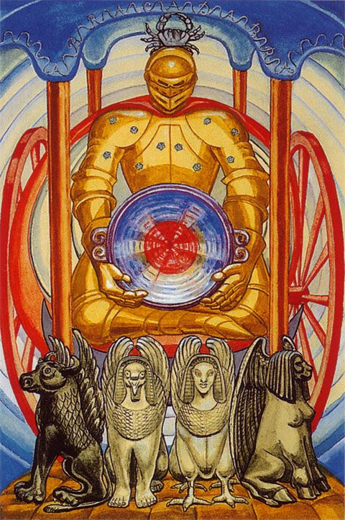
This is a graphic of the Chariot Atu from the Thoth Tarot. This imagery is important in the development of the ideas of the Adyton. Herein we see the Four Pillars upholding the canopy of Heaven, surrounding the Charioteer. Across it is written the word ABRAHADABRA, but within the context of the Aeon of MA, this word has become ANKAQOQAKNA.
Unlike Abrahadabra, ANKAQOQAKNA is a palindromic word, with no doubt about its spelling. It has the value of 414, which was first mentioned in MA 1:77. Because it is a palindrome, we can understand that the middle letter, “O”, as a pivot point. We have O which is 70, the EYE, and 344 which is the Hebrew word שלחו which means to send, or a dispatching of a message. Our next step is to make a Triad of 70 → 344 = 678, and we discover the TQ of “And through this Eye the entire cosmos is discovered in its Empty Net.”
In the Adyton these 10 letters symbolize the 10 spheres of the Pyramidion. They are split into pairs of 5 and 5, as follows:
- 319 + 366 + 350 + 452 + 685 = 2172, the binary sum of the Tarot of Amun
- 323 + 389 + 453 + 470 + 372 = 2007, the circumference of a circle whose radius is 319.
We then make a Triad, 2172 → 2007 = 2094. This is the result of adding the 2 factors of the Transgram between the two halves of the Holy Books, 457808 = 248 × 1846, where 248 + 1846 = 2094.
248 = the adyton of the seven
1846 = It has walls of seven, one foot thick, and the vault of heaven made of fire glazed brick It is strong and sturdy and withstands direct assault It is home to weary wanderers inside its very vault.
We then have 344, (the 10 letters) and the value of the Pyramidion, (4179). 344 → 4179 = 5344. This is a major nexus point. Looking at 5344, the sum of its factors is 10584, which is 4 × 2646, the result of the multiplication of the parts of a 7-sided Prism, which we saw above. It is also 7 × 1512, the number of unique English words in Liber MA.
It should be noted that 5344 is the sum of Liber Carrus, 1487, and Liber Arma, 3857. The Differential of 5344 > 3767 is 1577, the AIN SOPH! This is the ultimate root of the Tree of Life. And here we must end where we started. The Triad of 5524 → 5344 = 5785, the Greek word Mysterion in full –
Μυστηριον
5785 is the Reversal of 3803, όμικρον, omicron, in full, which is the letter of the Eye.
Omikrον
Taking the words Mysterion and Omikron in their normal values and making a Triad reveals the perimeter of the Adyton: 1178 > 360 = 1741, the antigram of 1295.

The Walls of the Adyton
Within the Adyton stand the Seven Walls, as Guardians and Watchtowers of our Mysteries. As I stated in my first treatise on the Adyton, the Walls represent the field in which the work of the Magician is accomplished. To review:
The Walls of the Adyton were designed to encapsulate the Venusian/Earth cyclic relationship. The Chamber of the Adept was designed to hold 40 Squares per Wall, the whole chamber then containing 280 squares. 280 is the value of ‘IOS’, the Arrow. 40 as 5x8 can be seen as the Venus/Earth Synodic relationship of 8 Venus synodic revolutions equaling 5 Earth years. In terms of triunes, Venus is 17, Sol is 13, summing 40. One could stop there and even reinterpret the Chamber of the Adepts with the AMUN Tree and other revelations that have been given to us. But as Liber MA exhorts…But proceed! proceed!
13 Venusian sidereal years are equivalent to 8 Terran years. We have elevated this from the geocentric 5/8 synchronicity of Earth/Venus to the heliocentric 8/13 synchronicity. On the wall, we can say that the rows are the Venus aspect of the 104 Array and the columns the Terran aspect of the 104 Array. The Walls of the Adyton are then structured according to the heptagonal arrangement of the Ditrunes. There are 728 Ditrunes, which is 104 when divided by 7. 104 is 8x13, so each wall is an array of 104 cells that have 8 rows and 13 columns. Thus, we attribute each of the 728 Ditrunes to a cell, according to their Zodiacal association on the Heptagons.
To be more technical, 8 and 13 are sequential Fibonacci numbers. Each wall then has a perimeter of 42. The total perimeter of all walls then being 7 x 42, equaling 294, the TQ of both these phrases: “the line in seven segments” & “the watch-towers of the Universe”.
104 is most famously the value of Tzaddi in full, and thus related to the Star card. The Converse of 104 is 624, and when 624 is multiplied by the Key Number, 133, we attain the sum of the Dance of Days calendar, 82,992. When we apply all this to the idea of Time, 104 years brings together 3 cycles that we will be addressing: the Thelemic Year of 365 days, the Dance of Days of 260 days, and the Venusian sidereal cycle of 584 days. Thus, 104 years equals 37960 days, which gives is 104 Thelemic years, 146 Dance of Days cycles, and 65 Venus cycles. Note that the Thelemic and Dance of Days calendar will align every 52 years, and this period is usually referred to as a Calendar Round, yet it takes 2 Calendar Rounds to unite it to the Venusian 584-day cycle.
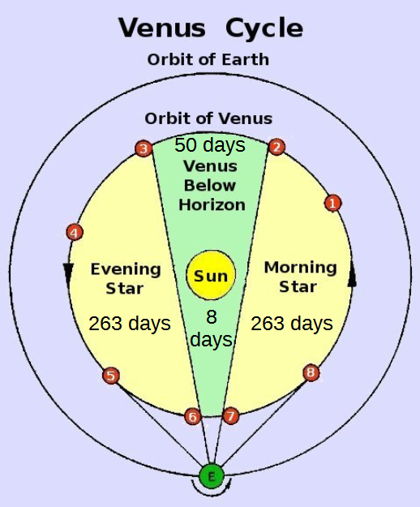
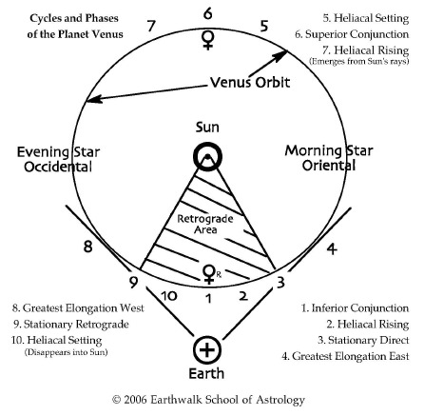
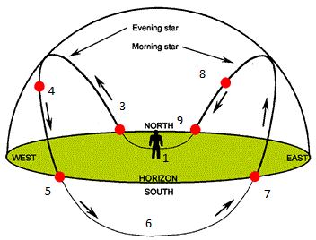
It is helpful to review the Venusian cycle and its different elements. The 584-day cycle starts at its Inferior Conjunction, when it is between Earth and Sol, (also the middle of its retrograde motion). The chart below diagrams this motion. The red indicates her retrograde motion, while the black is her direct motion. The yellow dot represents points of maximum brightness. It should be noted that Venus is hidden at either one of its conjunction points. At its Inferior Conjunction because it is in front of the sun, and her Superior Conjunction behind the sun. These are represented by points 1 and 6 in the second diagram.

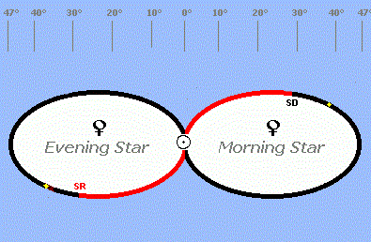

Hopefully these diagrams help to further your understanding of what the 584-day Venus cycle looks like from different perspectives. There are various measurements for the time that Venus spends in these different phases of her orbit. The most accepted are that she spends 526 days as Morning/Evening Star, and 58 days hidden. 526 is also the aliquot sum of 584, with its deficiency of 58. I find it remarkable that the numerical properties of this number encode the Venusian cycle. When we transition 584 -> 58, we attain 450, the numerical value of NU, in Greek.
It should first be noted, and quite profoundly, that the Venus point of Liber Carrus, DIO, equals 584 when spelled in full. The letters themselves equal 84, “I am Nuit” in TQ. The Rerune of 584 is 680, which is Zygos in Greek, the name of Libra. Just as important is the fact, as noted by Frater O.L. in Epistle 46, that 584 is the diameter of a circle whose area is the Global Sum of Liber L. Halving this gives us the radius, which is 292, “Linea virdis gyrat universa”.
The difference between the occulted 58 days of Venus and her 526 “Star” days is 468, the converse of 260. This is also DEMETER in Greek. In this we have a direct correspondence to the Dance of Days calendar. When Frater O.L. and I reinterpreted the Aztec Tzolkin in light of Trigrammic QBLH, it was hoped that it would shed further light on the prophetic nature of our System. It has indeed done that. Time is cyclic in nature, not linear.
This occulted period of 58 days is divided into 50 days behind the sun and 8 days in front of the sun. 8 -> 50 = 65, the number of 584-day cycles of Venus in 104 years, or 2 Calendar Rounds. This is 37960 days, which is the Decagram 1221001221, a ternary palindrome. 1221 is 52 in decimal, thus you have 52 over 52 with 2 Tao-lines between them. Another way to view this is the Hebrew letters Cheth and Nun. This forms the word ChN, which means grace or charm, attributes of Venus. This is also considered a notariqon for Chokmah Nesethrath, the Secret Wisdom. It should be well noted that these 2 letters in full equal 418 + 756, which is 1174, having 931, AMMON, as a differential.
We see here that there is a strong Venusian influence within the structure of the Planetary Watchtowers. She is in either Her Morning Star or Evening Star cycle for 263 days, and that is the 56th Prime, which is NV, the word of NV as six and fifty.
We learn in Liber L that the Five-Pointed Star is Nuit’s. I propose that this five-pointed Star is actually the pentagram created by Venus’s synodic cycle. In fact, in Greek, the term for five-pointed star is “Το Πεντάκτινο Αστέρι”, equaling 1872, whose reversal is 104. Structurally, 1872 is the septagram 2120100, thus hiding 120100, or 414, under the 7th Yin Line.
As stated above, the Watchtowers are composed of the 728 ditrunes arranged as pairs in the sevenfold regime. This creates 52 sets composed of 7 Ditrune pairs a piece. We refer to these as Zodiacal Heptagons, as each Ditrune Pair has a unique differential that is attributed to a degree on the Zodiac. The 4 Prime Ditrune pairs are not attributed to a degree but are the Equinoctial/Solstice points. The remaining 360 Conrune pairs are then attributed to the degrees of the Zodiac. One will note that 7 does not divide the circle into whole parts. This division of the Zodiac can only occur because of the Prime Ditrunes.
Much thought has been given to the structure of the walls. How to structure them in a perfectly balanced way, and it was not until the Trinity Operation that this was realized, and the alchemical formula of their structure was fully manifested. The key is the 4 Heptagon Sets that contain the Prime Ditrunes. And as it turns out, the Ditrunes tell us how they want to be structured in this matter. Below is the basic diagram of how the Ditrunes are attributed to the Walls. The numbers represent which Heptagon set the number is pulled from, with the lighter colors representing the Day Ditrune of the Conrune Pair, while the darker colors are the Night Ditrune of the set. It will be noticed the 39th Heptagon set is placed in the middle. This is done on purpose, as the control number of this Heptagon is 195, and this is the TQ value of Argentum Aurora, the sacred name of our Order.

 | 1 | 3 | 2 | 4 | 5 | 6 | 7 | 8 | 9 | 10 | 11 | 12 | 13
1 | 46 | 47 | 48 | 49 | 50 | 51 | 52 | 25 | 24 | 23 | 22 | 21 | 20
2 | 33 | 34 | 35 | 36 | 37 | 38 | 26 | 12 | 11 | 10 | 9 | 8 | 7
3 | 32 | 31 | 30 | 29 | 28 | 27 | 13 | 1 | 2 | 3 | 4 | 5 | 6
4 | 45 | 44 | 43 | 42 | 41 | 40 | 39 | 14 | 15 | 16 | 17 | 18 | 19
5 | 19 | 18 | 17 | 16 | 15 | 14 | 39 | 40 | 41 | 42 | 43 | 44 | 45
6 | 6 | 5 | 4 | 3 | 2 | 1 | 13 | 27 | 28 | 29 | 30 | 31 | 32
7 | 7 | 8 | 9 | 10 | 11 | 12 | 26 | 38 | 37 | 36 | 35 | 34 | 33
8 | 20 | 21 | 22 | 23 | 24 | 25 | 52 | 51 | 50 | 49 | 48 | 47 | 46

This gives the 7 middle column a total of 20748, which is 133 × 156, the 7 Planets as 133 and the 12 Zodiacal signs as 156. This means that what remains is 244608, which is 182 × 1344! 182 is the number given in Seven Spirits, while 1344 is the MIX Founding Heptagon whose founding was perpetuated by that document.
The planetary order of the walls shall be Saturn, Sol, Mercury, Luna, Venus, Juppiter, Mars. Luna shall be the Central Wall, with the whose central squares will be 470 > 613, the 143 Differential. This makes the Central column of all 7 walls 3534, which is Liber Graduum, Initium: 49 –
Thus is the cosmos revolving eternal. Thus is the center absorbing the Light. The Disk has been graven with images splendid, and each is a signal from one of the angels. Age after age is engraved on the edges, etched by the swords of the words of the aeons, spun by the fingers that clutched the sword hilt. And One is the finger that traced out the circle, One is the index that charted the course.
The Central Wall then has a total of 43068, 97 × 444, Amun × MQDSh, Sanctuary of Amun. Removing the Central Wall and summing the other 6 gives us 222288, 176 × 1263, 1263 being Gnosis. One last aspect to consider is the Central 2 rows, which I call the Belt of AMUN. This sums 67977, which is 91 × 747, the number of columns or AMN multiplied by the god of the Aeon, AMVN. The remaining 6 rows would then sum 197379, 117 × 1687
- 117 = the castle keep
- 1687 = Your Will is but a trajectory It is not a host of conditions It is not a nest of contradictions It is not choices based on reason. It is the orbit that can wind its way through the Labyrinth to the center.
We can then make the following chart to track these numbers:

 | Sum of Category | Sum of Remaining
Seven Columns | 20748 | 244608
Central Wall | 43068 | 222288
Belt of Amun | 67977 | 197379

These figures should be considered individually, separate from each other. There is one other thing we could consider, and that is separating the Belt of Amun and the Seven Columns, as their convergence is the central 2 squares of each wall, and this is the Å Founding Heptagon. Because this arrangement is composed of 224 cells, it will be called the Αιγισ (224) of the Watchtowers, or the Aegis of the Watchtowers.
The sum of these 224 cells is 83304, while the remaining 504 cells are 182052.
- 83304 = 104 × 801.
  - 104 is the number of cells per wall. 104 is also the TQ of Cauldron.
  - 801 is the TQ of “the skein of the golden coppery leaden silvery mercurial tinny and ferric veins”
  - We can then say that the Cauldron, which is central to the Vault of Hestia representing the square formed by the Pillars is the Mixing vessel of the 7 metals. The Triad of 104 → 801 = 1672 = 4 × 418, the Charioteer within the 4 Pillars.
- 182052 = 78 × 2334.
  - 78 is the Mystic Number of 12, and therefore can be seen as the Zodiac, and the light therefrom.
  - 2334 is the Reversal of 1162, the Word of the Aeon. It is also the TQ of Liber Graduum Finem: 56 –
Each of these sphinxes is guarding the temple the pharaoh has built from the dust of the Earth. For Nature provided the Stone for the building, the Light of the stars to be seen from within. Here he will marry his soul to the cosmos, here he will journey into the great void.
  - The Sphinxes of this verse are the four powers of the Adept mentioned in the previous verse (55). We could then say that each Watchtower has its own Aegis which divides it into Four Quarters, each Quarter guarded by a Sphinx.
To examine this further, we can divide Aegis number, 83304 into 2 parts, the Seven Pillars and the Belt of Amun, with one rule – the Å Heptagon will be counted as part of the Seven Pillars, and not included in the Belt of Amun. The 14 Ditrunes that compose this convergence point is 5421, the Reversal of 1391:
“That throne is the axle all the heavens and earth and planets and stars revolve around. As it is said ‘yon galaxy is but the smoke ring of mine incense”
This gives us 20748 for the Seven Pillars and 62556 for what remains of the Belt of Amun. 62556 = 12 × 5213. This is the Greek phrase “το άρρητον” in full. This Greek phrase translates to “the ineffable”. It refers to something that is inexpressible or unspeakable, often due to its sacred or immense nature. The Triad of 20748 → 62556 = 162648, the Reversal of 872 –
Λαβυριντηοσ
Labyrinthos – a Labyrinth
The Labyrinth as the geometric guardian of the Adyton, its Aegis.
The Planetary Order of the Walls
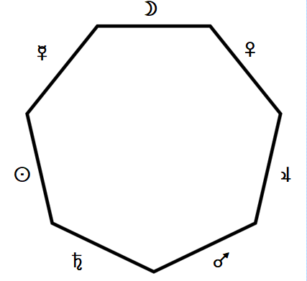
As stated above, the Planetary Order of the Walls shall be Saturn, Sol, Mercury, Luna, Venus, Juppiter, Mars, with Luna ruling the Central Wall. Technically, they are attributed to the Central Column of each Wall.

The order of the Planets is ordered to give the Lovely Star when the Liber MA order of the Metals is used to create the Lovely Star. As stated above, the sum of the Metals in Liber MA is 440, and this is the Reversal of 5976, the Seven Chakras; it is also the Differential of 185, the edge length of the perimeter of the Adyton. A detailed account of this arrangement can be found in Bulletin 33. An in-depth study of this Bulletin is suggested.
In respect to the Adyton, we can take the sum of the Seven Pillars, 20748, and the sum of the 4 Levels from Bulletin 33, 4369, thus integrating the 4 and the 7, and attain 25137, which is the Reversal of 1099! This is –

אמעון
Spelled in full.

The Cubical Altar
The Cubical Altar shall be based on the idea of the hypercube. The Altar itself symbolizes the visible universe and was placed at the center of the Hall of the Neophyte. Within the Adyton, the Charioteer is the focus, and the altar is displaced from the center. It then becomes symbolic of the multi-dimensional universe, and all that it implies.
The placement of the Altar is based on the proportions of the Polygon Ring. Their difference is 19, whose Key in the Tarot of Amun is the Dissolution Card. In short, any polygon ring can create a “hidden polygon” by taking the measurement at the vertices, its ‘thickness’, multiplying it by the number of vertices, and using this result as the circumcircle radius of a polygon with the same number of vertices. If one were to use the thickness of the edges instead, it gives you the incircle radius of the same polygonal result. Or one can simply multiply the differences between the 2 edge lengths by the number of vertices and get the edge length of the hidden polygon. In this case we have 7 × 19 = 133. This gives us a perimeter of 931, AMMON. This gives us a Circumcircle Radius of 153.2669, and a Circumcircle Circumference of 963.0041. 963 is AChD in Full (111 + 418 + 434). It is also the Hebrew phrase עטרת עטרה, meaning “the crown of the crown”. This can be esoterically interpreted as the most refined tier of the Crown Chakra, the Sahasrara Chakra. Achad has the meaning of 1, representing the Unity of the Crown Chakra. We then make a Triad of 1 → 963 = 1577, the Ain Soph! We can then understand that Hidden 133 Heptagon is the unifying principal that becomes the first gateway of manifestation, or Tao becoming yang.
Following this further, we create a hidden polygon ring between the Inner 166 Heptagon and the Hidden 133 Heptagon. This has a difference of 33. 7 × 33 = 231, the Mystic Number of 21, whose Tarot Key is the Water Atu. This gives us a heptagon whose perimeter is 1617, which is the Greek word ΣΧΙΞΩ, meaning “to rend (the veil)”. It is as if the Adyton is in a perpetual Sign of the Enterer. The Reversal of 1617 is 713, the TQ of “that the Seven might move indeed, yet ever point to the unchanging One”. It must be noted that this Heptagon exists outside the boundaries of the Adyton wall of 1295. This is the One of ACHAD in full, found as the circumference of the 133 Heptagon. The Seven are the 7 planetary Trigrams that total 133. We can also note that the Triad of One (47) → Seven (87) = 229, “it flows from all directions”. This saying pertains to the Word of the Aeon, Katalysis, as described in verse 0 & 1 of the Book of Dissolution.
We have then formed 4 Heptagons based on the geometry of the Adyton, two that are revealed, and two that are concealed. We then make a Triad of the Revealed and the Concealed – 2578 → 2457 = 2639, 7 × 377, 377 being the Hebrew word ShBVO, which is 7.
The traditional altar of the Adept has been a double cube. It was stated by Crowley that “the Altar must embody the Magician’s knowledge of the laws of Nature, which are the laws through which he works.” And further, “He should endeavor to make geometrical constructions to symbolize cosmic measurements”. The Altar as the tesseract does exactly that. Of the doubled cube, we read in Liber MA –
Then this doubled cube in its failure holds a key in it
The double cube, as the Altar, fails as the true nature of the Altar which, within the context of the Aeon of Ma, is a hypercube – not a cube on top of another cube. It shows a way in which to connect with the higher dimensions through its symbolism. We are no longer bound to the idea of directionality.
The Cubical Altar is based on a Hypercube, or Tesseract. There are 80 parts to a tesseract:
8 Cells + 24 Faces + 32 Edges + 16 Vertices
There is also a center, which has “no points nor parts nor magnitude”, and this can be considered the 81st part of the tesseract. These 81 parts can be aligned exactly with the 81 possible tetragrams of the ternary system. 3 types of line on 4 levels equals 3⁴ = 81. There is not only an exact match with the number of parts (81), but the types of tetragrams, based on how many zero digits are involved, has exactly the same subset numbers:
81 Tetragrams: 1 has 4 zeroes; 8 have 3 zeroes; 24 have 2 zeroes; 32 have 1 zero; 16 have no 0.
Each part of the tesseract is in a different dimension. The Cells are 3 D cubes; the Faces are 2 D squares; the Edges are 1 D lines, and the Vertices are 0 D points, (this means that only the ‘center’ is 4D, and this is reserved for the tetragram that is all Zeroes). So, in one sense, the 4 D hypercube is composed of 8 intertwined 3 D cubes, or Cells, which form the surface volume of the tesseract. Only 1 of these 8 Cells will be considered as the Cubical Altar of the Adyton.
Having these various parts in mind, the 8 Cells can be considered as individual cubes, which can be visualized by the following diagram:
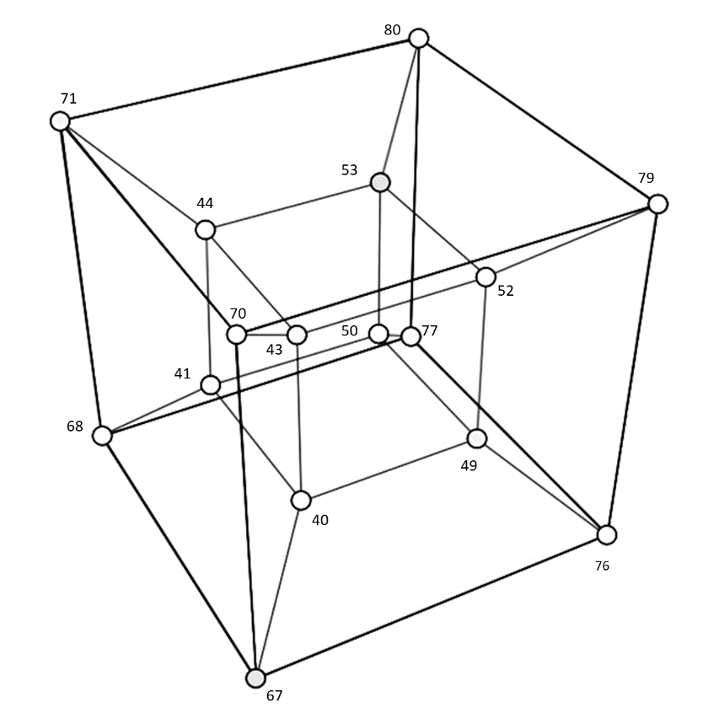
This is but one of many depictions of a hypercube. It represents the projection of the 8 corners of a regular cube into 4D space. It should be remembered that this is a projection only. The Tesseract contains 8 cubes. It should be kept in mind that each cube has its own function and importance. For the purposes of the Adyton, the cell of the Hypercube that will represent the Altar will be the Outer Cube.
In its simplest terms, the tesseract is constructed by first assigning tetragrams to the 16 Vertices. Then Transitional Triads are made between adjacent Vertices, to get the tetragram of the Edge that connects them. Finally, Vertices that are diagonally opposite each other on all the square Faces are transitioned through each other to get the value of the tetragram for each Face. Finally, each opposite Face is transitioned to get the tetragram for that particular Cell. In this way, all 80 parts of the tesseract are perfectly aligned with all 80 possible tetragrams, with no duplicates, and no missing numbers.
Major Arcana
Order | Title | 4-gram | Nuke | Ternary |  | Title | 4-gram | Nuke | Ternary | Order
1 | The Magus | 80 | 728 | 1 |  | Death | 68 | 608 | 701 | 13
2 | The Empress | 78 | 726 | 7 |  | The Devil | 66 | 606 | 14 | 14
3 | The Emperor | 79 | 727 | 5 |  | The Tower | 67 | 607 | 25 | 15
4 | The Hierophant | 75 | 696 | 4 |  | Aspiration | 50 | 455 | 16 | 16
5 | The Lovers | 77 | 698 | 485 |  | Providence | 49 | 454 | 472 | 17
6 | Art | 76 | 697 | 607 |  | The Priestess | 48 | 453 | 8 | 18
7 | Lust | 70 | 637 | 391 |  | Dissolution | 42 | 393 | 634 | 19
8 | Adjustment | 71 | 638 | 458 |  | The Star | 43 | 394 | 17 | 36
9 | Fortune | 69 | 636 | 23 |  | The Moon | 44 | 395 | 26 | 37
10 | The Chariot | 52 | 484 | 472 |  | The Sun | 40 | 364 | 13 | 38
11 | The Hermit | 51 | 483 | 620 |  | The Universe | 39 | 363 | 22 | 39
12 | The Hanged Man | 53 | 485 | 634 |  | The Aeon | 41 | 365 | 16 | 40
Minor Arcana
41 | Princess of Cups | 73 | 667 | 647 |  | Princess of Disks | 61 | 547 | 688 | 55
42 | Ace of Cups | 74 | 668 | 728 |  | Ace of Disks | 59 | 518 | 715 | 56
43 | Love | 72 | 666 | 646 |  | Change | 57 | 516 | 691 | 57
44 | Abundance | 65 | 578 | 638 |  | Works | 58 | 517 | 697 | 58
45 | Luxury | 64 | 577 | 644 |  | Power | 34 | 304 | 689 | 59
46 | Disappointment | 63 | 576 | 698 |  | Worry | 33 | 303 | 473 | 60
47 | Pleasure | 46 | 424 | 700 |  | Success | 35 | 305 | 475 | 61
48 | Debauch | 47 | 425 | 692 |  | Failure | 30 | 273 | 481 | 62
49 | Indolence | 45 | 423 | 476 |  | Prudence | 31 | 274 | 643 | 63
50 | Happiness | 38 | 335 | 482 |  | Gain | 32 | 275 | 635 | 64
51 | Satiety | 37 | 334 | 484 |  | Wealth | 24 | 240 | 637 | 65
52 | Prince of Cups | 36 | 333 | 719 |  | Prince of Disks | 25 | 241 | 716 | 66
53 | Queen of Cups | 60 | 546 | 727 |  | Queen of Disks | 26 | 242 | 718 | 67
54 | Knight of Cups | 62 | 548 | 725 |  | Knight of Disks | 21 | 210 | 724 | 68
69 | Princess of Wands | 23 | 212 | 445 |  | Princess of Swords | 20 | 182 | 404 | 83
70 | Ace of Wands | 22 | 211 | 364 |  | Ace of Swords | 18 | 180 | 401 | 84
71 | Dominion | 15 | 150 | 446 |  | Peace | 19 | 181 | 377 | 85
72 | Virtue | 16 | 151 | 454 |  | Sorrow | 10 | 91 | 395 | 86
73 | Completion | 17 | 152 | 448 |  | Truce | 9 | 90 | 403 | 87
74 | Strife | 12 | 120 | 394 |  | Defeat | 11 | 92 | 619 | 88
75 | Victory | 14 | 122 | 392 |  | Science | 7 | 61 | 617 | 89
76 | Valour | 13 | 121 | 400 |  | Futility | 6 | 60 | 611 | 90
77 | Swiftness | 56 | 488 | 616 |  | Interference | 8 | 62 | 449 | 91
78 | Strength | 55 | 487 | 610 |  | Cruelty | 5 | 32 | 457 | 92
79 | Oppression | 54 | 486 | 608 |  | Ruin | 3 | 30 | 455 | 93
80 | Prince of Wands | 28 | 244 | 373 |  | Prince of Swords | 4 | 31 | 376 | 94
81 | Queen of Wands | 29 | 245 | 365 |  | Queen of Swords | 2 | 2 | 374 | 95
82 | Knight of Wands | 27 | 243 | 367 |  | Knight of Swords | 1 | 1 | 368 | 96

Vertices | Faces
Edges | Cubes

As we know, there are 8 possible cubes, one of which will be exiled into the Adyton, while the other 7 will remain in their multi-dimensional state. This means that we must examine what this means. The 8 Cubes are as follows:

Card # | Title | Tetra | Nuke | Tern
96 | Knight of Swords | 1 | 1 | 368
95 | Queen of Swords | 2 | 2 | 374
93 | Ruin | 3 | 30 | 455
90 | Futility | 6 | 60 | 611
87 | Truce | 9 | 90 | 403
84 | Ace of Swords | 18 | 180 | 401
82 | Knight of Wands | 27 | 243 | 367
79 | Oppression | 54 | 486 | 608

Seeking the necessity of precision, diligence shows that the best option is the 10 of Wands, whose tetragram is 54. It should be noted that the card title, Oppression, is misleading and is a little outdated. Its divinatory meaning shows us the weight of life’s struggles and the burden they bring, yet it is also their completion after a long journey. Applied to the Altar, it lends the meaning of the responsibility of the Adept and the due diligence they must attain to complete the Great Work. It is a 10, therefore it represents completion. It is fire; therefore, it represents purification.
In Liber LUXORAT, the 10 of Wands is verse A:10, the Solar chapter –
At the peak of the Arrow, the smooth point gleams – the pyramidion enlightening the world.
The Altar is then representative of the smooth point, within which the other 7 Cubes of the Altar are concealed. The sum of the nuclear hexagrams for the Cubes are 606, which in turn is the nuclear hexagram of the Devil Atu. It should be noted that on traditional Tarot cards, he is shown as sitting on a double cube. We then form a Triad of 486 → 606 = 726, which is the nuclear hexagram of the Empress Atu. This is the “Seventy to her Four”
Symbolically, the Adept sitting on the Throne represents the pyramidion of the tetrahedral Throne, which represents the element of Fire as shown above. The pyramidion is represented by the number 4179 as shown above. We then make a Triad of 486 → 4179 = 5658, the reversal of 1886. 1886 is the Greek word Ευχαριστοσ, Eucharistos. Yet the Key is examining 5658 as a differential. This gives us the following Quadset:

14268 | 8610
3116 | 5986

We find that its reverse Differential is 2870! 2870 is the surface area of a hypercube whose surface volume is the Global Sum of the Holy Books of MIX. 2870 is 10 × 287, which we have noted is “the Cubical Altar of the Universe”. That traditional cubical altar is considered to have 10 sides. 5658 is also 41 × 138. 138 is the number of Cards in the esoteric Decanal Tarot of the MIX, being the 97 cards of the Tarot of Amun + 36 cards to represent the Decans as groups of 10 days + the 5 epagomenal days. This means that 41 cards were added to the 97 cards giving us 138 cards. 5658 then equals the number of cards added, 41, multiplied by the grand total of cards it produces (138) by adding them to the Tarot of Amun.
5658 gives us the relationship between the adept as the Pyramidion and the Cubical Altar, whose key to understanding is the Decanal Tarot. This relationship is contained within a heptagon whose perimeter is 1295. We then make a Triad of 1295 → 5658 = 3463, the 485th Prime (485 = 5 × 97). This is the Reversal of 3829, which is the sum of the letters, in full, of Liber Carrus, 7 × 547 = Panta Rei.
When we exile this cube, we can also look at what remains in terms of the sum of the nuclear hexagrams. This idea can only be applied to Cubes, as all the “numbers” are used more than once. Faces are shared between 2 Cubes, Edges are shared between 3 Faces, and Vertices are shared between 4 Edges. The only occurrence that is unique is the Cube numbers. The sum of the nuclear hexagrams is 29484. The nuclear value of the 10 of Wands is 486. 29484 – 486 = 28998. This number is 81 × 358. 358 is the sum of the Differentials of 27 Sag, the present Galactic Center (270), towards which the Adyton is oriented, and its “south pole” at 27 Gemini (88). It should be noted that the Trios of these 2 degrees sum 1450, the Reversal of 970.
More importantly, this number 28998 is the Reversal of 418, the Chariot! Thus, confirming the purpose of the Adyton, as a commemoration of the Adept as the Charioteer. We take this one step further, as one could argue that 29484 does not count all the individual occurrences of a Nuclear Hexagram.
 | Tetragram | Nuke | # Used | Total Tetra | Total Nuke
Verices | 960 | 8736 | 4 | 3840 | 34944
Edges | 1440 | 13104 | 3 | 4320 | 39312
Faces | 720 | 6552 | 2 | 1440 | 13104
Cubes | 120 | 1092 | 1 | 120 | 1092
Totals | 3240 | 29484 |  | 9720 | 88452

The Grand Total of all Nuclear Hexagrams when counted in this way equals 88452, the reversal of 364. We then remove 486, giving us 87966. This number is the Reversal of 526, which is the TQ of “I was the priest of Ammon-Ra in the temple of Ammon-Ra at Thebai.” This is the Adept as “the priest of Ammon-Ra” in the Adyton, which is “the temple of Ammon-Ra” at Thebai. Thebai is Thebes, and it is the Theban Triad whose gods are invoked through the formulation of Liber MA. Transliterated to Hebrew, as ThHBAI, this word equals 418. We can also make a Triad of 486 → 88452 = 175446. This number is the Reversal of 566, Tikkun.
We can take all this symbolism of the Altar and say that the Altar is the instrument by which the Adept, as the Charioteer, implements Tikkun, or restoration. The Altar is placed at 153, the rounded radius of the Hidden 133 Heptagon. Since the Altar is represented by 486 and centered at this point, we make a Triad of 153 → 486 = 441, AMTh, Truth.
Having established the Altar, we shall now examine its particulars. From the charts above, the Cubical Altar of the Adyton is constructed using the cards assigned to the tetragrams of the Outer Cube of the Tesseract.

The Vertices

70 | Lust
68 | Death
67 | The Tower
71 | Adjustment
77 | The Lovers
76 | Art
80 | The Magus
79 | The Emperor

The Vertices are all Major Arcana. The sum of the letters attributed to these is 243, which is the Greek word κορβαν, meaning an offering made to a deity, which is placed on an Altar. The Tetragrams that compose the vertices sum 588. This is a number rich in symbolism. A whole document could be written about its virtues. In respect to these mysteries, it is the M Trigram over the M Trigram:

M | m | A | a
M | m | A | a
 | 588 |  | 140

588 reverses to 140 and becomes MA by reversal. They sum 728, the total number of the Ditrunes. In TQ, 588 equals the following from Liber MA – “the lauds of the Bastion, and the sweet mastery of the Space of Ma.” The volume of a Tesseract can be considered “the space of MA”.

The Edges

58 | Works
59 | Ace of Disks
61 | Princess of Disks
62 | Knight of Cups
64 | Luxury
65 | Abundance
66 | The Devil
69 | Fortune
73 | Princess of Cups
74 | Ace of Cups
75 | The Hierophant
78 | The Empress

These edges total 804, which is the Greek word αγω, which is a geometric term of drawing a line. It is cognate with the Latin term, ago, meaning “I Act”. The Reversal of 804 is 460, which is:
I AM the force behind NU & NU is the breath of what I AM

The Faces
60 | Queen of Cups
57 | Change
72 | Love
63 | Disappointment
56 | Swiftness
55 | Strength

The value of the Tetragrams that form the Faces of this cube sum 363, “the set of facets of a jewel in many planes”.
We are then able to make a simple sum of the parts of the Altar:
- Vertices = 588
- Edges = 804
- Faces = 363
- Cube = 54
The total of 1809 is the Reversal of 41, MA. 41 is also the number of Major Atus in the Indestructible Tarot of Amun. 1809 is also 9 × 201, and this is MA in full, or “Understand MA”. This Reversal set is then “understood” as MA in Her simple addition, and as MA in full. 1809 is also BITh QDSh spelled in Full, meaning Holy House.
Upon the top of the altar shall be a 4 × 4 checkered design, alternating blue and green colors. We read in the Book of Dissolution: 42 –
“Both red ink and black are equal. Now the writing may be done in blue and green.”
In terms of accounting, red ink represents debt and black ink represents profit. Blue is then the color of what we are responsible for, and green is the color of growth. The red ink becomes blue, while the black ink becomes green.
The structure of the Tarot of Amun is such that 81 of the cards represent the 81 Tetragrams of base 3. This then leaves 16 Cards not represented by the 81 lines of Liber Trigrammaton. Yet the question remains, what to do with these additional 16 cards. The answer is hinted at in the structure of the 97 Ditrune itself. It is 81 over the 16 Ditrune. This has been gone over extensively by the Seer in both his private and public writings. These 16 cards then become the 16 Tetragrams of Binary and become the gear by which the Tetragrams of Ternary are created. We can then confirm that these 16 Binary Tetragrams are represented on the Altar in a 4 × 4 Magic Square as follows:
G | T | N | H
B | O | Y | S
P | A | Z | F
X | M | J | W

Or in its binary equivalent:
1100 | 0010 | 0001 | 1111
0111 | 1001 | 1010 | 0100
1011 | 0101 | 0110 | 1000
0000 | 1110 | 1101 | 0011

12 | 2 | 1 | 15
7 | 9 | 10 | 4
11 | 5 | 6 | 8
0 | 14 | 13 | 3

Card Number | TQ of Title | Card | Greek Title | Isopsephy | Binary Tetragram
20 | 39 | Fire | Πυρ | 580 | 15
21 | 49 | Water | Υδωρ | 1304 | 0
22 | 44 | Earth | Γη | 11 | 10
23 | 19 | Air | Αηρ | 109 | 2
24 | 40 | Libra | Ζυγοσ | 680 | 12
25 | 57 | Virgo | Παρθενοσ | 515 | 5
26 | 55 | Scorpio | Σκορπιοσ | 750 | 1
27 | 47 | Aries | Κριοσ | 400 | 9
28 | 75 | Capricorn | Αιγοκερωσ | 1209 | 6
29 | 108 | Sagittarius | Τοξοτησ | 1008 | 11
30 | 60 | Cancer | Καρκινοσ | 471 | 7
31 | 49 | Pisces | Ιχθυεσ | 1224 | 3
32 | 105 | Aquarius | Υδροχοοσ | 1514 | 14
33 | 24 | Leo | Λεων | 885 | 8
34 | 93 | Taurus | Ταυροσ | 1071 | 4
35 | 69 | Gemini | Διδυμοι | 538 | 13
440 | 933 |  |  | 12269 | 120

The total decimal value of the binary values is 120, which is the TQ of “chessboard”, which is the Σ 0-15. Adding 120 to the rest of the deck, 36249, equals 36369. This is 81 × 449, which in TQ is “Keep the structure intact, but open the doors.”. 81 here can indicate the 81 tetragrams in ternary, which is the ‘structure’, yet ‘the doors’ (97) are opened by the addition of the 16 binary tetragrams. We have 81: the number of Ternary Tetragrams, and 16: the number of Binary tetragrams. Forming a Triad 16 -> 81 = 185, the Conrune of 97, “the doors”.
There is a much deeper mystery surrounding all of this, since a tesseract can be made from the Global Sum of the Holy Books of Mix. The value of a single face of the Holy Books of MIX tesseract is 2870 = 10 × 287, 287 = “the Cubical Altar of the Universe”. When we apply the sum of these Binary Tetragrams to the value of a face, we form the following Triad, 120 -> 2870 = 4663. This is the 631st Prime, and in TQ, we have the following – “My words are truth; they celebrate Your power, O Khonsu the Great”.
Turning to what is concealed, we look at the Reversal of this number 4663 and discover it to be 2765, which is Liber Graduum, Caput Medium: 71, a most fitting gematria indeed!
“Just as the ancient Egyptians have shown you the side and the front and the side once again. So too in this dream are the faces of the cube given to you at once. All is beheld in a singular vision a higher dimension revealing its view. This is the web of the wondrous spider, alive with the fire of the crackling wood.”
Looking at the Quadset of this number, we find that the Differential Transgram is 1493, which is the sum of 440, the sum of the Atu Keys, plus 993, the TQ of the English of the Titles of these Keys, plus 120 equals 1493.
We note that these are Atus 20 through 35, and this series of numbers sum 440, which is the Conrune of 625 (see above). In this, we refer to the names of the Elements and Zodiac in Greek. They sum 12269, which is the 1467th Prime, 1467 is the value of the 4 corners of the Pyramidion of the Adept. We can then see that Amun is within these 16 aspects. Further, when we make a Triad out of the Binary value of these 16 Tetragrams, 120, and the ternary value, 960: 120 → 960 = 1467. Thus, 1467 represents the transition of the 16 Tetragrams from one base to another base, from 2-base to 3-base, and then 1467 as a Prime Ordinal gives us the total of these 16 Tetragrams in their Greek Equivalents.
Yet here is the fundamental synthesis of these ideas. Looking at the 12269 quadset, we find that it has a Septad number of 68880, the surface area the Hypercube of the Holy Books of Mix:
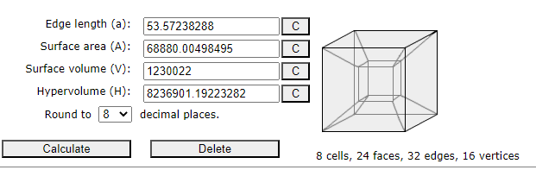
We now look at which one of the Faces we shall use to represent the communion of the 16 Binary tetragrams and the 81 Ternary Tetragrams creating the Altar’s relationship to the Pyramidion. These faces are as follows:
Card | 4-Gram | Nuke
Queen of Cups | 60 | 546
Change | 57 | 516
Love | 72 | 666
Disappointment | 63 | 576
Swiftness | 56 | 488
Strength | 55 | 487
Totals | 363 | 3279

The sum of the Tetragrams is 363, so the question remains which of these faces is best to represent the Chessboard of the 16 Binary Tetragrams. After due diligence, it proves that the Lord of Love is the most favorable of options. The Binary of this card is 17, so we can represent the relationship of 17 → 120 = 226, “I who was a priest of Ammon-Ra” & “NU is the breath of what I AM”. Also interesting is the fact that 93, the number used to represent the previous Aeon, plus 133, the number used to represent the present Aeon, equals 226. The Conrune of 226 is 128, AL-AMVN.
363 – 72 = 291. 291 = 3 × 97. This number represents the internal generator of the Adyton Tesseract. It will be shown later how 291³ is concealed in the Grand Amalgamation of the Adyton. In TQ, 291 is “O hidden one, the Lord Amun!”. When we make a Triad of 72 → 291 = 510, from which we have the Hebrew word IShR, meaning to make straight, and just conduct. It is the idea of MA’AT in Action, which is AMVNH.
The Nuclear Hexagram for this is 666, which is the first actual use of this number in our Gnosis. Its appearance here is both a remainder and a correction. It is a remainder of the Old Aeon and all its Apocalyptic alack. Mankind was destined to fail under this paradigm, that all was hopeless and bleak. The correction is then at its core, 666 is the mystic number of 36, thus it has a solar nature. Its aliquot sum is 816. This is an essential nature of 666 as a number. 816 we saw as the Differential of 825 (Adyton in Greek) > 1641 (the sum of the Gods of the 3 Chapters of Liber MA). 816 is also the Hebrew word מתושע which refers to an enneagram. Thus, we can examine 666 in the sense of an enneagram. When we make 666 the perimeter, we have an edge length of 74, which is Lamed. This corresponds to the Star of Lamed used on the Ceiling.
We can then calculate the Triplicity of Triples. Each triangle would then have an edge length of 562.125, rounding to 562. The value of 562 in TQ is Peacock:19 –
“I have come to destroy the old ways and to reveal a new gnosis”
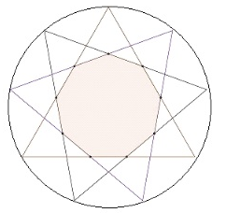
562 is also the Conrune of 287, “the Cubical altar of the Universe”. We then have an edge length of all 3 triangles equaling 1686. 1686 > 861, AION, and has a differential of 825, ADYTON.
This means that 666 is an Abundant number whose abundance is 150, and this is the Hebrew word “nest”. We can this interpret this dynamic as “the Nest of the Enneagram”. The Circumference of the Nest would then be 679, 7 × 97. 679 is the TQ of the verse of Liber LUXORAT attributed to the 2 of Cups, O:2 –
The Mother returns, feeding her offspring from the blood of her heart
This nest is pictured on the Empress Atu. This is a reference to the Pelican’s Sacrifice myth, the mother being the Empress. This is a symbol of self-sacrifice, whose ultimate expression is Agapé. Armed with this information, we can now reinterpret 666 according to the geometry of the Enneagram. There is a lot implied here. It is 9 × 74. Adjustment is the 9th card of the Amun Tarot sequence. 666 is then a reference to the Adjustment card in terms of the Tarot of Amun, as 666 is the Hebrew letter value, in full, times its card’s positional value. 666 is no longer a number that represents the Apocalypse, or anything to do with it, in the context of the Aeon of MA. Under the New Gnosis, 666 is a number that represents, simply, Agape. This is the Title of the 2 of Cups in the Greek Tarot. We can then make the Triad 93 → 666 = 249 –
The word of the law is Θελημα

The Grand Synthesis of Adyton
Taking a step back, we have 3 Adornments that can be synthesized that exist within the 1162 Heptagon. We first look at the Four Pillars and the Altar. These are 2542 for the Pillars and 1148 for the Altar, summing 3690.
To this is added the number of Aspects that compose the Netzach Tetrahedron from which we formed the Throne, 84, summing a total of 3774, the Reversal of 1330, Amun in Kether. Above we saw that 1330 is the Diameter of a circle whose circumference is 4179, the 10 Aspects of the Pyramidion. Adding these two Reversals gives us 5104, as 8 × 319. We saw this number above as Transitional Sum of this Pyramidion as 4296 and its Reversal 808.
This all happens within the 1162 Heptagon, so we make a Triad of 1162 → 3774 = 4904
Καταλυσισ
In full

Epilogue
In the traditional tarot, the Major Arcana contains a cast of characters in a highly symbolic tableau. In this procession, only two cards are objects: the Chariot and the Tower. In the former, a hidden figure sits and holds the Grail. In the latter, human figures are seen falling from the parapets as the Tower explodes. This card has been given more different names than any other card: Sagitta (Arrow); la Casa del Diavolo (House of the Devil); Fulmine (Lightning); Fuoco (Fire); la Casa del Danato (House of the Damned); Inferno (Hell); la Casa di Plutone (House of Pluto); la Foudre (Lightning) and la Maison Dieu (the House of God, or ‘God House’).
The last of these names was used in the Tarot de Marseilles, which heavily influenced the Golden Dawn, and in turn the work of Crowley. While all the other names in Italian refer to fiery things, hell, the underworld etc., and the idea of lightning even carries over into one of the early French decks, this last term is the most curious, and yet the most fitting for our purpose. The French term is usually translated as the House of God, but since grammar rules were not fixed in those early days, the name can also be God House. And this term has a specific meaning in medieval France. A ‘God House’ was a place of refuge, a hospital for poor pilgrims, a place of sanctuary and comfort. It might even refer to a Church, a place to encounter the Divine Spirit.
It is precisely this function of the God House that is the purpose of the Adyton. While it most certainly can be the home of fire and lightning, these forces are emanated from within the Tower, not struck by it from above. And the reason these forces do so is because the Adept is within the Tower, taking refuge from the world, and communing with their Angel. The Tower is therefore the Temple, and in this essay that Temple has been described in the utmost detail. The components of the Temple are both simple and complex: 4 Pillars of the elements and the Sphinxes; a Cubical Altar that is in 4 dimensions; and a 4-sided polyhedron, sliced off to make a seat for the Adept, surrounded by the 7 walls, and the heptagonal floor with its letters of power, and the heptagonal ceiling with its heptagram of enlightenment. For Lightning is one of the most appropriate of names for the Tower, in respect of the fact that the Tower is a 7-sided prism, designed to refract and convey the messages of the Star Goddess.
Whether it is called the Adyton of the 7, the Vault of the Adepts, the Well of the Seven, or the Bastion, it is still the same building with the same purpose: a fortress of refuge for weary wanderers, and a place where the science of Trigrammaton mixes with the Art of the Aeon.
The Tower is a recurring theme in the Holy Books of M.I.X., and many of the details of its construction and purpose can be found in these scriptures. All of these details of the Tower have been worked out thoroughly in this outstanding compilation. Frater M.G. has collated an immense amount of data to form the basis of the science of the Adyton. And what the Adept does within this space is the Art of our gnosis. May this essay serve the Adept well, in their journey of discovery through the labyrinth of time, and the sweet mastery of the Space of MA.
I thoroughly endorse this essay, and consider it the equivalent of the required thesis of a Magister Templi 8⊗3, the Grade which Frater M.G. has attained, and which he has duly earned by his unflagging devotion to the Work.
Omega Logion 9⊗2

